

Name: _______________________________________
Class: __________ Teacher: ______________________

Don’t Ask Jack by Neil Gaiman

This story is set in the past and is about some children and their relationship with a rather unusual toy.


Nobody knew where the toy had come from - which great-grandparent or distant aunt had owned it before it was given to the nursery. It was a box, carved and painted in gold and red. It was undoubtedly attractive and, or so the grown-ups maintained, quite valuable – perhaps even an antique. The latch, unfortunately, was rusted shut, and the key had been lost so the Jack could not be released from his box. Still, it was a remarkable box, heavy and carved and gilt.
The children did not play with it. It sat at the bottom of the old wooden toy box, which was the same size and age as a pirate’s treasure-chest, or so the children thought. The Jack-in-the-box was buried beneath dolls and trains, clowns and paper stars and old conjuring tricks, and crippled marionettes with their strings irrevocably tangled, with dressing up clothes (here the tatters of a long-ago wedding dress, there a black silk hat, crusted with age and time) and costume jewellery, broken hoops and tops and hobbyhorses. Under them all was the Jack’s box.
The children did not play with it. They whispered among themselves, alone in the attic nursery. On grey days when the wind howled about the house and rain rattled the slates and pattered down the eaves they told each other stories about Jack, although they had never seen him. One claimed that Jack was an evil wizard, placed in the box as punishment for crimes too awful to describe; another maintained that he had been placed in the box as guardian to prevent the bad things inside it from coming out. They would not even touch the box, if they could help it, although when, as happened from time to time, an adult would comment on the absence of that sweet old Jack-in-the-box, and retrieve it from the chest, and place it in a position of honour on the mantelpiece, then the children would pluck up their courage and, later, hide it away once more in the darkness.
The children did not play with the Jack-in-the-box. And when they grew up and left the great house, the attic nursery was closed up and almost forgotten.
Almost, but not entirely. For each of the children, separately, remembered walking alone in the moon’s blue light, on his or her own bare feet, up to the nursery. It was almost like sleepwalking, feet soundless on the wood of the stairs, on the threadbare nursery carpet. Remembered opening the treasure chest, pawing through the dolls and the clothes and pulling out the box.
And then the child would touch the catch, and the lid would open, slow as a sunset, and the music would begin to play, and Jack came out. Not with a pop and a bounce: but deliberately, intently, he would rise from the box and motion to the child to come closer, closer, and smile.
And there in the moonlight, he told them each things they could never quite remember, things they were never able entirely to forget.
The oldest boy died in the Great War. The youngest, after their parents died, inherited the house, although it was taken from him when he was found in the cellar one night with cloths and paraffin and matches, trying to burn the great house to the ground. They took him to the madhouse, and perhaps he is there still.
The other children, who had once been girls and now were women, declined, each and every one, to return to the house in which they had grown up; and the windows of the house were boarded up; and the doors were all locked with the huge iron keys.
Years have passed and the girls are old women, and owls and bats have made their homes in the old attic nursery, rats build their nests among the forgotten toys. The creatures gaze uncuriously at the faded prints on the wall, and stain the remnants of the carpet with their droppings.
And deep within the box within the box, Jack waits and smiles, holding his secrets. He is waiting for the children. He can wait forever.

The Flowers by Alice Walker

This is a coming-of-age tale, written in 1973, which contrasts the innocence of a young, African-American girl with the harsh and grim realities of the adult world. The events occur on a summer’s day, somewhere in the United States, at a time after the abolition of slavery.


It seemed to Myop as she skipped lightly from hen house to pigpen to smokehouse that the days had never been as beautiful as these. The air held a keenness that made her nose twitch. The harvesting of the corn and cotton, peanuts and squash, made each day a golden surprise that caused excited little tremors to run up her jaws.
Myop carried a short, knobby stick. She struck out at random at chickens she liked, and worked out the beat of a song on the fence around the pigpen. She felt light and good in the warm sun. She was ten, and nothing existed for her but her song, the stick clutched in her dark brown hand, and the tat-de-ta-ta-ta of accompaniment.
Turning her back on the rusty boards of her family’s sharecropper cabin, Myop walked along the fence till it ran into the stream made by the spring. Around the spring, where the family got drinking water, silver ferns and wildflowers grew. Along the shallow banks pigs rooted. Myop watched the tiny white bubbles disrupt the thin black scale of soil and the water that silently rose and slid away down the stream.
She had explored the woods behind the house many times. Often, in late autumn, her mother took her to gather nuts among the fallen leaves. Today she made her own path, bouncing this way and that way, vaguely keeping an eye out for snakes. She found, in addition to various common but pretty ferns and leaves, an armful of strange blue flowers with velvety ridges and a sweet suds bush full of the brown, fragrant buds.
By twelve o’clock, her arms laden with sprigs of her findings, she was a mile or more from home. She had often been as far before, but the strangeness of the land made it not as pleasant as her usual haunts. It seemed gloomy in the little cove in which she found herself. The air was damp, the silence close and deep.
Myop began to circle back to the house, back to the peacefulness of the morning. It was then she stepped smack into his eyes. Her heel became lodged in the broken ridge between brow and nose, and she reached down quickly, unafraid, to free herself. It was only when she saw his naked grin that she gave a little yelp of surprise.
He had been a tall man. From feet to neck covered a long space. His head lay beside him. When she pushed back the leaves and layers of earth and debris Myop saw that he’d had large white teeth, all of them cracked or broken, long fingers, and very big bones. All his clothes had rotted away except some threads of blue denim from his overalls. The buckles of the overalls had turned green.
Myop gazed around the spot with interest. Very near where she’d stepped into the head was a wild pink rose. As she picked it to add to her bundle she noticed a raised mound, a ring, around the rose’s root. It was the rotted remains of a noose, a bit of shredding plowline, now blending benignly into the soil. Around an overhanging limb of a great spreading oak clung another piece. Frayed, rotted, bleached, and frazzled–barely there–but spinning restlessly in the breeze. Myop laid down her flowers.
And the summer was over.

Lamb to the Slaughter by Roald Dahl

Set in 1950s Britain, Roald Dahl’s chilling but humorous short story describes the dramatic events which take place after a husband delivers some devastating news to his devoted wife.

The room was warm, the curtains were closed, the two table lamps were lit. On the cupboard behind her there were two glasses and some drinks. Mary Maloney was waiting for her husband to come home from work. Now and again she glanced at the clock, but without anxiety: she merely wanted to satisfy herself that each minute that went by made it nearer the time when he would come home. As she bent over her sewing, she was curiously peaceful. This was her sixth month expecting a child. Her mouth and her eyes, with their new calm look, seemed larger and darker than before.

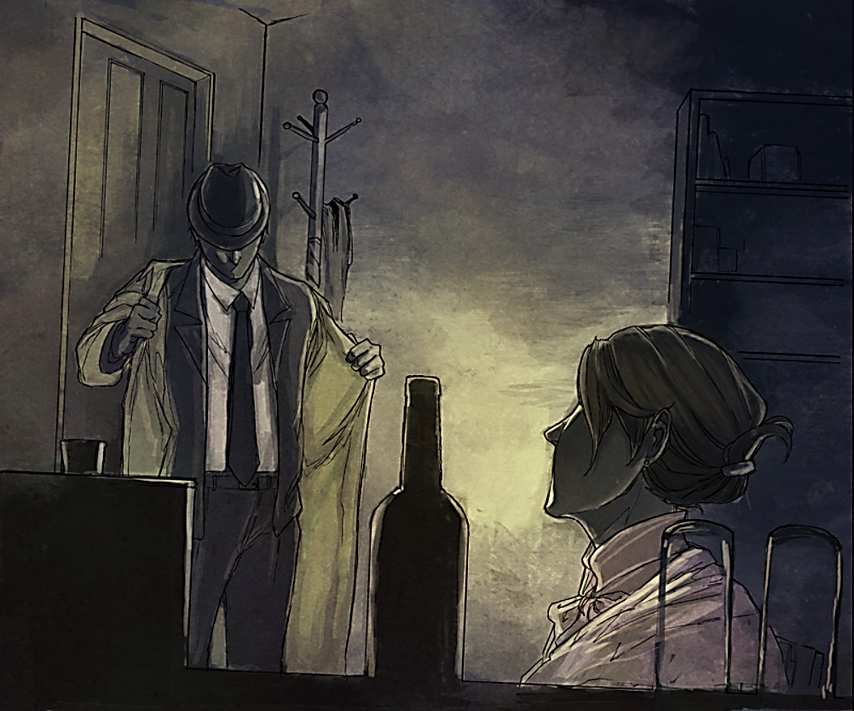
When the clock said ten minutes to five, she began to listen, and a few moments later, punctually as always, she heard the car tires on the stones outside, the car door closing, footsteps passing the window, the key turning in the lock. She stood up and went forward to kiss him as he entered.

"Hello, darling," she said.
"Hello," he answered.
She took his coat and hung it up. Then she made the drinks, a strong one for him and a weak one for herself; and soon she was back again in her chair with the sewing, and he was in the other chair, holding the tall glass, rolling it gently so that the ice knocked musically against the side of the glass.


For her, this was always a wonderful time of day. She knew he didn't want to speak much until the first drink was finished, and she was satisfied to sit quietly, enjoying his company after the long hours alone in the house. She loved the warmth that came out of him when they were alone together. She loved the shape of his mouth, and she especially liked the way he didn't complain about being tired.

"Tired, darling?"
"Yes," he sighed. "I'm thoroughly exhausted. And as he spoke, he did an unusual thing. He lifted his glass and drank it down in one swallow although there was still half of it left. He got up and went slowly to get himself another drink.
"I'll get it!" she cried, jumping up.
"Sit down," he said.
When he came back, she noticed that the new drink was a very strong one. She watched him as he began to drink.
"I think it's a shame," she said, "that when someone's been a policeman as long as you have, he still has to walk around all day long." He didn't answer. "Darling," she said," If you're too tired to eat out tonight, as we had planned, I can fix you something. There's plenty of meat and stuff in the freezer." Her eyes waited for an answer, a smile, a nod, but he made no sign. "Anyway," she went on. "I'll get you some bread and cheese."
"I don't want it," he said.
She moved uneasily in her chair. "But you have to have supper. I can easily fix you something. I'd like to do it. We can have lamb. Anything you want. Everything's in the freezer."
"Forget it," he said.
"But, darling, you have to eat! I'll do it anyway, and then you can have it or not, as you like." She stood up and placed her sewing on the table by the lamp.
"Sit down," he said. "Just for a minute, sit down." It wasn't until then that she began to get frightened.
"Go on," he said. "Sit down."
She lowered herself into the chair, watching him all the time with large, puzzled eyes. He had finished his second drink and was staring into the glass.
"Listen," he said. "I've got something to tell you."
"What is it, darling? What's the matter?"
He became absolutely motionless, and he kept his head down. "This is going to be a big shock to you, I'm afraid," he said. "But I've thought about it a good deal and I've decided that the only thing to do is to tell you immediately." And he told her. It didn't take long, four or five minutes at most, and she sat still through it all, watching him with puzzled horror.

"So there it is," he added. "And I know it's a tough time to be telling you this, but there simply wasn't any other way. Of course, I'll give you money and see that you're taken care of. But there really shouldn't be any problem. I hope not, in any case. It wouldn't be very good for my job."
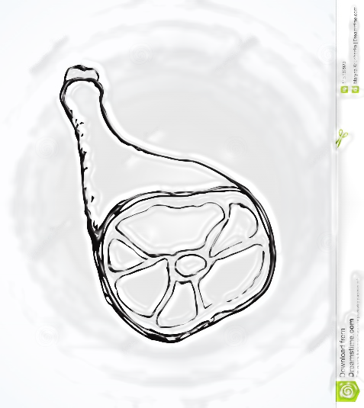
Her first instinct was not to believe any of it. She thought that perhaps she'd imagined the whole thing. Perhaps, if she acted as though she had not heard him, she would find out that none of it had ever happened. "I'll fix some supper," she whispered.

When she walked across the room, she couldn't feel her feet touching the floor. She couldn't feel anything except a slight sickness. She did everything without thinking. She went downstairs to the freezer and took hold of the first object she found. She lifted it out, and looked at it. It was wrapped in paper, so she took off the paper and looked at it again --- a leg of lamb. All right, then, they would have lamb for supper. She carried it upstairs, held the thin end with both her hands. She went into the living room, saw him standing by the window with his back to her, and stopped.
"I've already told you," he said. "Don't make supper for me. I'm going out."

At that point, Mary Maloney simply walked up behind him and without any pause, she swung the big frozen leg of lamb high in the air and brought it down as hard as she could on the back of his head. She might as well have hit him with a steel bar.
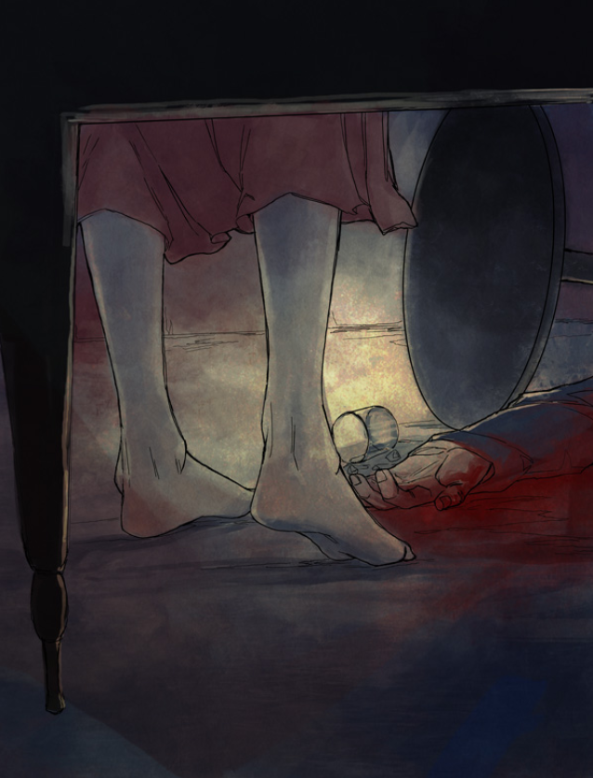
She stepped back, waiting, and the strange thing was that he remained standing there for at least four or five seconds. Then he crashed onto the carpet.

The violence of the crash, the noise, the small table overturning, helped to bring her out of the shock. She came out slowly, feeling cold and surprised, and she stood for a few minutes, looking at the body, still holding the piece of meat tightly with both hands. All right, she told herself. So I've killed him.

It was extraordinary, now, how clear her mind became all of a sudden. She began thinking very fast. As the wife of a detective, she knew what the punishment would be. It made no difference to her. In fact, it would be a relief. On the other hand, what about the baby? What were the laws about murderers with unborn children? Did they kill them both -- mother and child? Did they wait until the baby was born? What did they do? Mary Maloney didn't know and she wasn't prepared to take a chance.

She carried the meat into the kitchen, put it into a pan, turned on the oven, and put the pan inside. Then she washed her hands, ran upstairs, sat down in front of the mirror, fixed her makeup, and tried to smile. The smile was rather peculiar. She tried again."Hello, Sam" she said brightly, aloud. The voice sounded peculiar, too. "I want some potatoes, Sam. Yes, and perhaps a can of beans." That was better. Both the smile and the voice sounded better now. She practised them several times more. Then she ran downstairs, took her coat, and went out the back door, through the garden into the street.

It wasn't six o'clock yet and the lights were still on in the neighbourhood grocery. "Hello, Sam," she said brightly, smiling at the man in the shop.
"Good evening, Mrs. Maloney. How are you?"
"I want some potatoes, please, Sam. Yes, and perhaps a can of beans, too. Patrick's decided he's tired and he doesn't want to eat out tonight," she told him. "We usually go out on Thursdays, you know, and now I don't have any vegetables in the house."
"Then how about some meat, Mrs. Maloney?" asked the grocer.
"No, I've got meat, thanks, I've got a nice leg of lamb, from the freezer."
"Do you want these potatoes, Mrs. Maloney?
"Oh, yes, they'll be fine. Two pounds, please."
"Anything else?" The grocer turned his head to one side, looking at her. "How about dessert? What are you going to give him for dessert? How about a nice piece of cake? I know he likes cake."
"Perfect," she said. "He loves it."
And when she had bought and paid for everything, she gave her brightest smile and said, "Thank you, Sam. Good night."

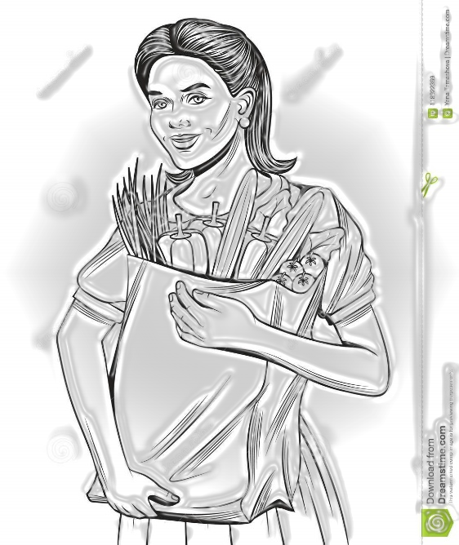
And now, she told herself as she hurried back home, she was returning to her husband and he was waiting for his supper. She had to cook it well and make it taste as good as possible, because the poor man was tired; and if she found anything unusual or terrible when she got home, then it would be a shock and she would have to react with grief and horror. Of course, she was not expecting to find anything unusual at home. She was just going home with the vegetables on Thursday evening to cook dinner for husband. That's the way, she told herself. Do everything normally. Keep things absolutely natural and there'll be no need for acting at all. As she entered the kitchen by the back door, she was quietly singing to herself.

"Patrick!" she called. "How are you, darling?"
She put the package on the table and went into the living room; and when she saw him lying there on the floor, it really was a shock. All the old love for him came back to her, and she ran over to him, knelt down beside him, and began to cry hard. It was easy. No acting was necessary.

A few minutes later, she got up and went to the phone. She knew the number of the police station, and when the man at the other end answered, she cried to him. "Quick! Come quickly! Patrick's dead."
"Who's speaking?"
"Mrs. Maloney. Mrs. Patrick Maloney."
"Do you mean that Patrick's dead?"
"I think so," she cried. "He's lying on the floor and I think he's dead."
"We'll be there immediately," the man said.

The car came very quickly, and when she opened the front door, two policemen walked in. She knew them both. She knew nearly all the men at the police station. She fell into Jack Noonan's arms, crying uncontrollably. He put her gently into a chair.
"Is he dead?" she cried.
"I'm afraid he is. What happened?"
In a few words she told her story about going to the grocer and coming back, when she found him on the floor. While she was crying and talking, Noonan found some dried blood on the dead man's head. He hurried to the phone.

Soon, other men began to come into the house. First a doctor, then two detectives, one of whom she knew by name. Later, a police photographer arrived and took pictures, and a man who knew about fingerprints. There was a great deal of whispering and muttering beside the corpse, and the detectives kept asking her a lot of questions. But they always treated her kindly. She told her story again, this time right from the beginning, when Patrick had come in, and she was sewing, and he was tired, so tired he hadn’t wanted to go out for supper. She told how she’d put the meat in the oven — “it’s there now, cooking” — and how she’d slipped out to the grocer for vegetables, and come back to find him lying on the floor.
“Which grocer?” one of the detectives asked.
She told him, and he turned and whispered something to the other detective who immediately went outside into the street. In fifteen minutes he was back with a page of notes, and there was more whispering, and through her sobbing she heard a few of the whispered phrases — “...acted quite normal...very cheerful...wanted to give him a good supper...peas...cheesecake...impossible that she...”

After a while, the photographer and the doctor departed and two other men came in and took the corpse away on a stretcher. Then the fingerprint man went away. The two detectives remained, and so did the two policemen. They were exceptionally nice to her, and Jack Noonan asked if she wouldn’t rather go somewhere else, to her sister’s house perhaps, or to his own wife who would take care of her and put her up for the night.
No, she said. She didn’t feel she could move even a yard at the moment. Would they mind awfully if she stayed just where she was until she felt better? She didn’t feel too good at the moment, she really didn’t.
Then hadn’t she better lie down on the bed? Jack Noonan asked.
No, she said. She’d like to stay right where she was, in this chair. A little later, perhaps, when she felt better, she would move.

So they left her there while they went about their business, searching the house. Occasionally one of the detectives asked her another question. Sometimes Jack Noonan spoke to her gently as he passed by. Her husband, he told her, had been killed by a blow on the back of the head administered with a heavy blunt instrument, almost certainly a large piece of metal. They were looking for the weapon. The murderer may have taken it with him, but on the other hand he may have thrown it away or hidden it somewhere on the premises.
“It’s the old story,” he said. “Get the weapon, and you’ve got the man.”

Later, one of the detectives sat down beside her. Did she know, he asked, of anything in the house that could have been used as a weapon? Would she look around to see if anything was missing? A very big spanner, for example, or a heavy metal vase. They didn’t have any heavy metal vases, she said.
“Or a big spanner?” She didn’t think they had a big spanner. But there might be some things like that in the garage.

The search went on. She knew that there were other policemen in the garden all around the house. She could hear their footsteps on the gravel outside, and sometimes she saw a flash of a torch through a chink in the curtains. It began to get late, nearly nine she noticed by the clock on the mantle. The four men searching the rooms seemed to be growing weary, a trifle exasperated.

“Jack,” she said, the next time Sergeant Noonan went by. “Would you mind giving me a drink?”
“Sure, I'll give you a drink. You mean this whiskey?”
“Yes please. But just a small one. It might make me feel better.” He handed her the glass.
“Why don’t you have one yourself,” she said. “You must be awfully tired. Please do. You’ve been very good to me.”
“Well,” he answered. “It’s not strictly allowed, but I might take just a drop to keep me going.”
One by one the others came in and were persuaded to take a little nip of whiskey. They stood around rather awkwardly with the drinks in their hands, uncomfortable in her presence, trying to say consoling things to her.
Sergeant Noonan wandered into the kitchen, came out quickly and said, “Look, Mrs. Maloney. You know that oven of yours is still on, and the meat is still inside?”
“Oh dear me!” she cried. “So it is!”
“I better turn it off for you, hadn’t I?”
“Will you do that, Jack? Thank you so much.”
When the sergeant returned the second time, she looked at him with her large, dark tearful eyes. “Jack Noonan,” she said.
“Yes?”
“Would you do me a small favour — you and these others?”
“We can try, Mrs. Maloney.”
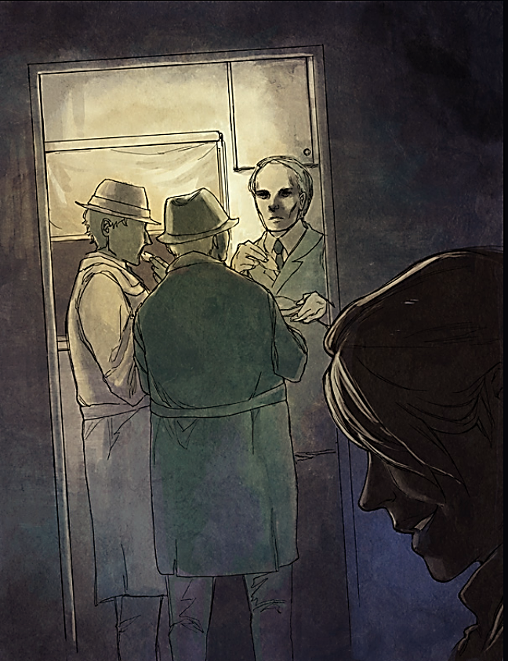
“Well,” she said. “Here you all are, and good friends of dear Patrick’s too, and helping to catch the man who killed him. You must be terribly hungry by now because it’s long past your suppertime, and I know Patrick would never forgive me, God bless his soul, if I allowed you to remain in his house without offering you decent hospitality. Why don’t you eat up that lamb that’s in the oven. It’ll be cooked just right by now.”
“Wouldn’t dream of it,” Sergeant Noonan said.
“Please,” she begged. “Please eat it. Personally I couldn’t touch a thing, certainly not what’s been in the house when he was here. But it’s all right for you. It’d be a favour to me if you’d eat it up. Then you can go on with your work again afterwards.”

There was a good deal of hesitating among the four policemen, but they were clearly hungry, and in
the end they were persuaded to go into the kitchen and help themselves. The woman stayed where
she was, listening to them speaking among themselves, their voices thick and sloppy because their
mouths were full of meat.
“Have some more, Charlie?”
“No. Better not finish it.”
“She wants us to finish it. She said so. Be doing her a favour.”
“Okay then. Give me some more.”
“That’s the hell of a big club the guy must’ve used to hit poor Patrick,” one of them was saying. “The doc says his skull was smashed all to pieces just like from a sledgehammer.”
“That’s why it ought to be easy to find.”
“Exactly what I say.”
“Whoever done it, they’re not going to be carrying a thing like that around with them longer than they need.”
One of them belched.
“Personally, I think it’s right here on the premises.”
“Probably right under our very noses. What do you think, Jack?”

And in the other room, Mary Maloney began to giggle.

Ruthless by William de Mille

In this story, set in the North American wilderness, a man devises a plan to protect his belongings.


Outside, the woods lay in clear October sunlight: the autumn air was full of the sharp, exciting smell of moist, leaf-covered earth. Inside, a man smiled grimly as he turned from the bathroom cabinet, entered the primitive living room of his mountain camp, and crossed to a closet set in the pine wall.
It was his special closet with a spring lock, and in it he kept guns, ammunition, fishing rods and liquor. Not even his wife was allowed to have a key, for Judson Webb loved his personal possessions and became furious if they were touched by any hand but his own.
The closet door stood open: he had been packing his things away for the winter, and in a few minutes he would be driving back to civilization.
As he looked at the shelf on which the liquor stood, his smile was not attractive. All the bottles were unopened, except one quart of Bourbon which was placed invitingly in front, a whiskey glass by itself. The bottle was less than half full. As he took it from the shelf, his wife spoke from the next bedroom. “Everything is packed, Judson,” she said. “Hasn’t Alec come to turn the water off and get the keys?”
Alec lived about a mile down the road and acted as a caretaker for the city folks when they were away.
“He’s down at the lake taking the boats out of the water. He said he’d be back in half an hour.”
Mabel came into the room carrying her suitcase. But she paused in surprise as she saw the bottle in her husband’s hand. “Judson!” she exclaimed, “You’re not taking a drink at ten o’clock in the morning, are you?”
“You’re wrong, my dear,” he chuckled, “I’m not taking anything out of this bottle; I’m only putting something into it.” His closed hand opened, and he put two tiny white tablets on the table as he started to uncork the whiskey.
Her eyes narrowed as she watched him. She had learned to dread that tone of his voice; it was the tone he used when he was planning to “put something over” in business.
“Whoever broke into my closet last winter and stole my liquor will probably try it again once we are out of here,” he went on, “only this time he’ll wish he hadn’t.”
She caught her breath at this cruel vindictiveness as one by one he dropped the tablets into the bottle and held it up to watch them dissolve.
“What are they?” she asked, “something to make him sick?”
“And how!” He seemed fascinated as he saw the Bourbon changing into a deadly drink. “At least no one has found an antidote: once it’s down, it’s the end.”
He corked the bottle and set it back on the shelf alongside the little whiskey glass. “Everything nice and handy,” he remarked, “now, Mr. Thief, when you break in, have a good drink; I won’t begrudge you this one.”
The woman’s face was pale. “Don’t do it, Judson,” she gasped, “it’s horrible – it’s murder.”
“The law doesn’t call it murder if I shoot a thief who is entering my house by force,” he said harshly. “Also, the use of rat poison is not forbidden. The only way any rat can get into this closet is to break in. What happens then has nothing to do with me.”
“Don’t do it, Judson,” she begged, “the law doesn’t punish burglary by death; so what right have you?”
“When it comes to protecting my property, I make my own laws.” His deep voice was like that of a big dog growling at the possible loss of a bone.
“But all they did was to steal a little liquor,” she pleaded, “probably some boys off on a lark. They didn’t do any real damage.”
“That’s not the point,” he said. “If a man holds me up and robs me of five dollars, it makes me just as sore as if he took a hundred. A thief’s a thief.”
She made one last effort. “We won’t be here till next spring. I can’t bear to think of that death-trap waiting there all the time. Suppose something happens to us – and no one knows.”
He chuckled once more at her words. “We’ll take a chance on that,” he said. “I’ve made my pile by taking chances. If I should die, you can do as you please. The stuff will be yours.”
It was useless to argue – she knew. He had always been ruthless in business and whenever anything crossed him. Things had to be done his way. She turned towards the door with a sigh.
“I’ll walk down the road and say goodbye at the farmhouse,” she said quietly, “you can pick me up there.” She had made up her mind to tell Alec’s wife. Someone had to know. “Okay, my dear,” he smiled, “and don’t worry about your poor little burglar. No one is going to get hurt who hasn’t got it coming to him.
As she went down the path, he started to close the closet door, and then paused as he remembered his hunting boots outside on the porch. They belonged in the closet. So, leaving the door open, he went to fetch them from the heavy, rustic table on which they stood, along with his bag and top coat.
Alec was coming up from the lake and waved to him from a distance.
A chipmunk, hearing Judson’s heavy tread, left the acorn it was about to add to its store within the cabin wall and disappeared.
When reaching for his boots, Judson stepped upon that acorn. His foot slid from under him and his head struck the massive table as he fell.

Several minutes later, he began to regain his senses. Alec’s strong arm was supporting his head as he lay on the porch, and a kindly voice was saying, “It wasn’t much of a fall, Mr. Webb. You aren’t cut none; just knocked out for a minute. Here, take this. It’ll pull you together.”
A small whiskey glass was pressed to Judson’s lips. Dazed and half-conscious he drank.

The Topiary Enthusiast by Jan Rooke

This short story describes a woman’s actions as she waits for her husband to return home.
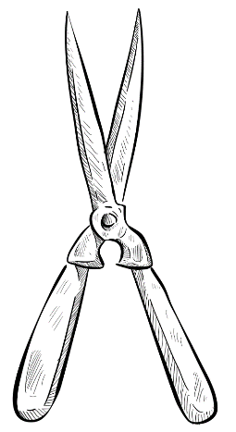
The fog deepened, descending over the sleepy village, muffling the country sounds of birds preparing to roost. The shadows lengthening in the garden added a sinister air to the topiary animals, cloaking them in mystery.

She stood listening for the gravel and the sound of his key in the door.

The grandfather clock in the hall struck seven, making her start as she peered around the wine-coloured velvet drapes. The smell of pastry drifted in from the kitchen. A rich steak and kidney pie, his favourite, would spoil if he didn’t get home soon. From across the fields the church clock repeated the hour, its chimes hollow and ghostly.

A car sloshed its way down the empty lane, making her hold her breath for a few seconds. It drove past. She gave a loud sigh and made her way to the tiny kitchen. After turning the oven down she prodded a potato. It fell apart.

Later, pouring herself a large sherry, she wandered round the dining room, half-heartedly laying the table. The darkness was gathering outside the large leaded window. Crossing the room, it seemed to her that the absurd bushes she hated so much hovered in the gloom outside like malevolent spirits. What was the point in clipping a hedge to look like a squirrel or a cockerel? With his job in London and the hours he spent driving backwards and forwards, he hardly had time for her as it was, without spending every free moment making those monstrosities that held their eerie court outside. She could feel them watching her, judging her.

Her resentment, simmering on a low heat all these years, suddenly cooled to icy fear as she caught sight of his hedging shears waiting by the back door. The church clock struck eight. A solitary dog barked. She downed her sherry in a gulp, then, taking the bottle with her, walked back into the lounge. There was another newsflash on the television, a pile-up on the southbound carriage of the M3. Turning the volume down, she stood for a while with the light off and the curtains parted, noticing for the first time how busy the tiny country lane was. At each low engine purr and stab of headlights her heart quickened, only to slow again as the car drove past.

As the clock struck ten she drew the curtains and locked the front door. In the kitchen, the uneaten food thrown away, the dishes stacked for washing, she carefully cleaned a tiny drop of brake fluid from the shears before hiding them under the sink.

Taking the sherry upstairs with her, she was surprised at how calm she now felt. She opened her bedroom curtains for one last look. The fog had lifted and a clear, starry sky shone down on the police car turning into her drive.

The Whole Town’s Sleeping by Ray Bradbury

This is an extract from a short story set in 1950s Illinois. The protagonist, Lavinia, is a single woman residing in a town that has been living in fear of a serial killer called The Lonely One. Lavinia has been dismissive of these fears and, on the evening the story is set, has visited the cinema with friends, despite police warnings. At this point, she is finally alone and walking home across a ravine.

She took a step. There was an echo. She took another step.
Another echo. Another step, just a fraction of a moment later.
“Someone’s following me,” she whispered to the ravine, to the black crickets and dark-green hidden frogs and the black stream. “Someone’s on the steps behind me. I don’t dare turn around.”
Another step, another echo.
“Every time I take a step, they take one.” A step and an echo.
Weakly she asked of the ravine, “Officer Kennedy, is that you?”
The crickets were still.
The crickets were listening. The night was listening to her. For a change, all of the far summer-night meadows and close summer-night trees were suspending motion; leaf, shrub, star, and meadow grass ceased their particular tremors and were listening to Lavinia Nebbs’s heart. And perhaps a thousand miles away, across locomotive-lonely country, in an empty way station, a single traveller reading a dim newspaper under a solitary naked bulb, might raise up his head, listen, and think, What’s that? and decide, Only a woodchuck, surely, beating on a hollow log. But it was Lavinia Nebbs, it was most surely the heart of Lavinia Nebbs.
Silence. A summer-night silence which lay for a thousand miles, which covered the earth like a white and shadowy sea. Faster, faster! She went down the steps. Run!
She heard music. In a mad way, in a silly way, she heard the great surge of music that pounded at her, and she realised as she ran, as she ran in panic and terror, that some part of her mind was dramatising, borrowing from the turbulent musical score of some private drama, and the music was rushing and pushing her now, higher and higher, faster, faster, plummeting and scurrying, down, and down into the pit of the ravine.
Only a little way, she prayed. One hundred eight, nine, one hundred ten steps! The bottom! Now, run! Across the bridge!
She told her legs what to do, her arms, her body, her terror; she advised all parts of herself in this white and terrible moment, over the roaring creek waters, on the hollow, thudding, swaying almost alive, resilient bridge planks she ran, followed by the wild footsteps behind, behind, with the music following, too, the music shrieking and babbling.
He’s following, don’t turn, don’t look, if you see him, you’ll not be able to move, you’ll be so frightened. Just run, run! She ran across the bridge.
Oh, God, God, please, please let me get up the hill! Now up the path, now between the hills, oh God, it’s dark, and everything so far away. If I screamed now it wouldn’t help; I can’t scream anyway. Here’s the top of the path, here’s the street, oh, God, please let me be safe, if I get home safe I’ll never go out alone; I was a fool, let me admit it, I was a fool, I didn’t know what terror was, but if you let me get home from this I’ll never go without Helen or Francine again! Here’s the street. Across the street! She crossed the street and rushed up the sidewalk. Oh God, the porch! My house! Oh God, please give me time to get inside and lock the door and I’ll be safe!
And there—silly thing to notice—why did she notice, instantly, no time, no time—but there it was anyway, flashing by—there on the porch rail, the half-filled glass of lemonade she had abandoned a long time, a year, half an evening ago! The lemonade glass sitting calmly, imperturbably there on the rail,. . . and . . .
She heard her clumsy feet on the porch and listened and felt her hands scrabbling and ripping at the lock with the key. She heard her heart. She heard her inner voice screaming.
The key fit.
Unlock the door, quick, quick! The door opened.
Now, inside. Slam it! She slammed the door.
“Now lock it, bar it, lock it!” she gasped wretchedly. “Lock it, tight, tight!”
The door was locked and bolted tight.
The music stopped. She listened to her heart again and the sound of it diminishing into silence.
Home! Oh God, safe at home! Safe, safe and safe at home! She slumped against the door. Safe, safe. Listen. Not a sound. Safe, safe, oh thank God, safe at home. I’ll never go out at night again. I’ll stay home. I won’t go over that ravine again ever. Safe, oh safe, safe home, so good, so good, safe!
Safe inside, the door locked. Wait.
Look out the window. She looked.
Why, there’s no one there at all! Nobody.
There was nobody following me at all. Nobody running after me. She got her breath and almost laughed at herself. It stands to reason if a man had been following me, he’d have caught me! I’m not a fast runner. . . There’s no one on the porch or in the yard. How silly of me. I wasn’t running from anything. That ravine’s as safe as any place. Just the same, it’s nice to be home. Home’s the really good warm place, the only place to be.
She put her hand out to the light switch and stopped.
“What?” she asked. “What, what?”
Behind her in the living room, someone cleared his throat.

Lather and Nothing Else by Hernando Téllez

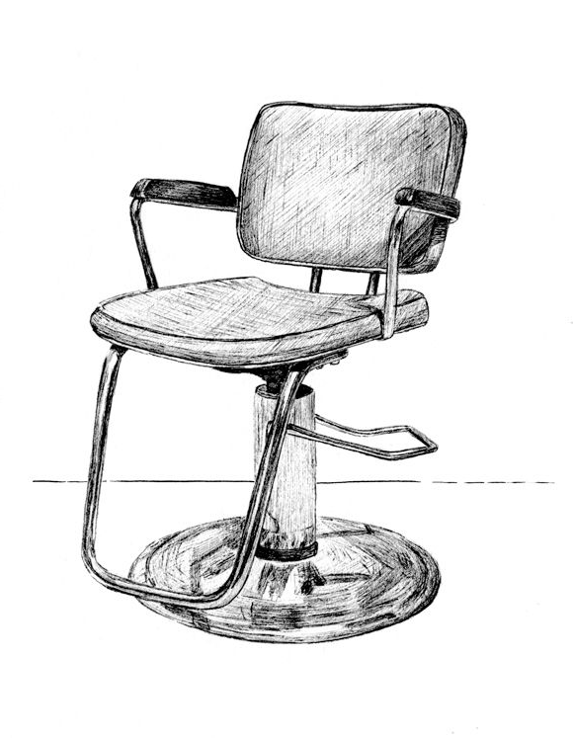
This story is translated from Hernando Tellez's original narrative which was written in Spanish. Set in a barbershop in a small Colombian town, the narrator is a barber tasked with shaving a man.

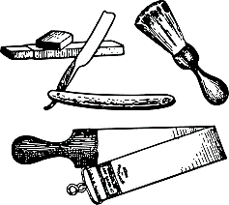
He did not say hello when he came in. I was polishing my best razor over a piece of leather. And when I recognized him, I started to shake. But he didn't notice. To hide it, I continued polishing the blade. I tested it with the tip of my thumb and turned to look at him against the light. At that moment he was taking off his belt with his bullet-holder where his holster was hanging. He hung it on one of the clothes pegs and on top of that, placed his vest. He turned all the way around to address me, and, undoing the knot of his tie, told me: "It’s hot as hell. Give me a shave." And he sat down in the chair. I figured he had about four days’ worth of growth. Four days on his most recent excursion in search of our men. His face appeared burnt, weather-beaten by the sun. I started to meticulously prepare the soap. I cut a few slices from the bar, dropping them into the container, I mixed it with a bit of warm water, and I began to mix it with the brush. The foam soon started to rise.
"The guys in the troop must have as much of a beard as I do."
I continued blending the lather.
"But we came out well, you know? We caught the top dogs. Some came to us dead and others of them are still alive. But soon, they’ll all be dead."
"How many did you get?" I asked.
"Fourteen. We had to go in deep to run into them. But now it's paying off. Not one of them, not a single one, will be spared." He leaned back in his chair upon seeing me with the brush in hand, overflowing with lather. I hadn't put on the sheet. I was definitely flustered. I took out a sheet from the cabinet and tied it around my customer’s neck. He didn't stop talking. He assumed that I was one of his party members. "The town must have learned a lesson from what happened the other day," he said.
"Yeah," I responded while finishing doing the knot around his dark neck, smelling of sweat.
"It was good, wasn't it?"
"Very," I answered, while picking up the brush. The man closed his eyes with an expression of fatigue and waited just like that for the cool caress of the soap. I'd never had him so close to me. The day when he ordered the town to line up on the patio of the schoolyard to watch the four rebels hanging there, I crossed his path for an instant. But the spectacle of the mutilated bodies prevented me from concentrating on the face of the man who planned the whole thing, the face I now held in my hands. It wasn't an unpleasant face, certainly. And the beard, while it made him look a bit older, didn't look bad on him. His name was Torres. Captain Torres. A man with a good imagination – who else would have thought of playing target practice with the naked bodies of the rebels before hanging them? I started to apply the first layer of lather. He kept his eyes closed. "I really feel like taking a nap for a bit," he said, "but I have a lot to do this afternoon."
I put down the brush and asked, pretending not to be interested: "Executions?"
"Something like that, but slower," he responded.
"All of them?"
"No. Barely a few."
I went back to lathering his beard. My hands were shaking again. The man couldn't have noticed and that was my advantage. But I had hoped that he wouldn't come. A lot of our men had probably seen him come in. And having the enemy on your turf makes you act a certain way. I had to shave this beard like I would any other, with caution, with care, like that of any other regular, making sure that I did not spill even one drop of blood from a single pore. Making sure that the little circles of his beard didn't deflect the blade. Making sure that his skin remained clean, warm, polished, that when I passed the back of my hand over it, I would feel the surface without a single hair. Yes. I was a secret revolutionary, but I was still a barber of conscience, proud of the cleanliness of my profession. And this four-day-old beard would make for a job well done.
I took the razor, raised the two handles at an oblique angle, let the razor go, and started the task, working my way down on one of the sideburns. The blade responded perfectly. The hair proved tough and hard, not very long, but compact. His skin started appearing little by little. The razor sounded with its typical sound, and upon it fell lumps of soap mixed with bits of stubble. I paused to clean off the razor, took the leather strap again and started to re-sharpen the steel, because I am a barber who does things well. The man had kept his eyes closed, opened them, put one of his hands on top of the sheet, felt the part of his face where the soap started to dry off, and told me: "Come to the schoolyard this afternoon at six."
"Will it be the same as the other day?" I asked, horrified.
"Maybe even better," he responded.
"What do you think you’re going to do?"
“I don’t know yet. But we’ll have fun.” He leaned back again and closed his eyes. I approached him with the blade raised up. “Do you think you’re going to punish them all?” I ventured timidly.
"All of them."
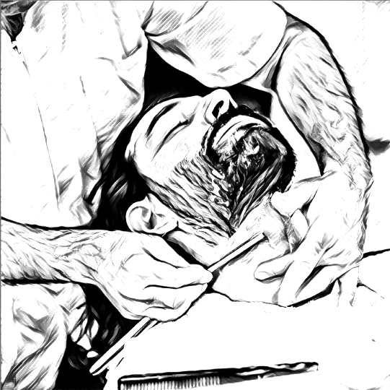
The soap was drying on his face. I had to hurry. I looked into the mirror at the street. The same as always: the grocery store with two or three customers inside. Then I looked at the clock: two-thirty in the afternoon. The blade continued its way down his face. Now I worked my way down the other sideburn. A blue, compact beard. He'd let it grow like some poets or priests. It looked good on him. Many wouldn't have recognized him. All the better for him, I thought, as I tried to softly polish all of his neck area. Because there I definitely needed to handle the blade well, since the hair, though not so tough, was tangled up in little whirls. A curly beard. The tiny pores could open up, and release their pearl of blood. A good barber like me is rightly proud of never letting this occur to any client. And this one was a first-class client. How many of us had he ordered killed? How many of us had he ordered mutilated? No. It was better not to think about it. Torres didn't know that I was his enemy. He didn’t know, nor did anyone else. I treated it as a secret and told only a select few, precisely so that I could inform the revolutionaries about what Torres was doing in the town and what he was planning to do every time he went out to hunt down revolutionaries. It was going to be very hard, then, to explain that I had him in my hands and I let him go, peacefully, alive, and clean-shaven.
His beard had disappeared from his face almost completely. He seemed younger, with a few years off his face than he had when he’d come in. I suppose that this always happens with men who come in and out of barbershops. Under the stroke of my razor Torres became young again, because I am a good barber, the best in this town, if I do say so myself.
A little bit more soap, here, under his chin, on his Adam’s apple, on that great big vein. God, it's hot! Torres must be sweating as much as I am. But he's not afraid. He's a calm man who doesn't even think of what he's going to have to do this afternoon with the prisoners. I, on the other hand, with razor in hand, polishing his skin again and again, avoiding spilling any blood from those pores, watching every stroke, can't think clearly. Damn the hour that he came in, because I am a revolutionary but not a murderer. And it would have been so easy to kill him. And he deserves it.
Does he deserve it? No, hell no! No one deserves to be the sacrifice that turns other people into murderers. What good could come of that? None, of course. More and more people come and the first group kills the second who killed the third, and it continues on and on until the world is a sea of blood.
I could slit his throat, just like that, bam! He wouldn't have time to groan in pain and since his eyes were closed, he wouldn't see the gleam of the razor or the gleam in my eyes. But I was shaking like a real murderer. A stream of blood would spill from his neck, onto the sheet, onto the chair, onto my hands, onto the ground. I would have to close the door. And the blood would continue on the floor, warm, permanent, unstoppable; onto the street, like a small scarlet brook. I am sure that with a strong stroke, a slicing cut, he wouldn’t feel any pain. He wouldn't suffer. But what would I do with the body? Where would I hide it? I’d have to run, leaving all of this, take cover far, far away. But they would follow me until they ran into me. "Captain Torres' murderer. He cut his throat while he was shaving him. What a coward."
But, on the other hand: "He avenged us. A name to remember (my name here). He was a barber of the people. No one knew that he was fighting for our cause…"
So what? Murderer or hero? My destiny depended all on this blade. I could tilt my hand a little more, leaning in the razor a little bit more, and plunge it in. His skin would give way like silk, like rubber, like leather. There's nothing more tender than human skin and the blood was always there, ready to spill out. A razor like this never fails you. It's my best razor.
But I don't want to be a murderer; no, sir. You came so that I could shave you. And I'm doing the job honourably… I don’t want to stain myself with blood. Just lather, and nothing else. You are an executioner; I'm just a barber. And to each his own. That's the way it is. To each his own.
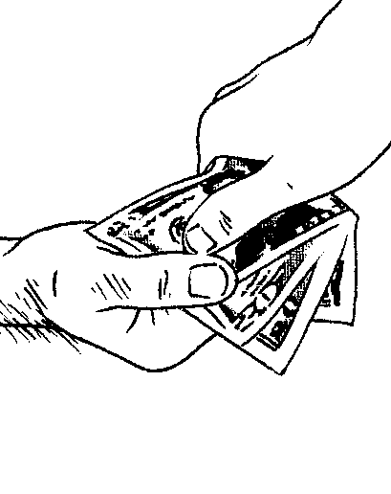
The beard had stayed clean, polished, and warm. The man sat up to look at himself in the mirror. He passed his hands over his skin and felt that it was fresh and renewed.
"Thanks," he said. He approached the clothes peg to look for his belt, his pistol, and his vest. I must have been very pale and I felt that my shirt was soaked with sweat. Torres finished adjusting his belt buckle, corrected the position of the pistol in his holster, and after mechanically smoothing out his hair, put on his vest. He took out some money from his pants pocket to pay me the cost of the services. He stopped in the doorway for a second, and turning to me, he said:
"They kept saying that you would kill me. I came to find out if it was true. But killing’s not easy. Believe me, I know." And he continued his way down the street.

The Tell-Tale Heart by Edgar Allan Poe

Written from the perspective of a murderous protagonist, this short story is widely regarded as one of the most iconic works of Gothic Literature by a 19th Century American author. Throughout the narrative, we hear the thoughts of the unnamed narrator who tries to convince the reader that he is sane while also describing a terrible crime that he has committed.

True!—nervous—very, very dreadfully nervous I had been and am; but why will you say that I am mad? The disease had sharpened my senses—not destroyed—not dulled them. Above all was the sense of hearing acute. I heard all things in the heaven and in the earth. I heard many things in hell. How, then, am I mad?
Hearken! and observe how healthily—how calmly I can tell you the whole story.
It is impossible to say how first the idea entered my brain; but once conceived, it haunted me day and night. Object there was none. Passion there was none. I loved the old man. He had never wronged me. He had never given me insult. For his gold I had no desire. I think it was his eye! Yes, it was this! He had the eye of a vulture—a pale blue eye, with a film over it. Whenever it fell upon me, my blood ran cold; and so by degrees—very gradually—I made up my mind to take the life of the old man, and thus rid myself of the eye forever.
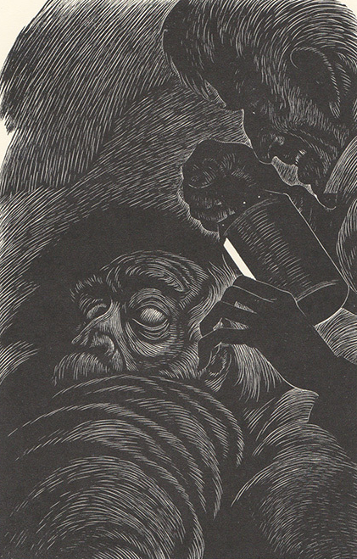
Now this is the point. You fancy me mad. Madmen know nothing. But you should have seen me. You should have seen how wisely I proceeded—with what caution—with what foresight—with what dissimulation I went to work! I was never kinder to the old man than during the whole week before I killed him. And every night, about midnight, I turned the latch of his door and opened it—oh so gently! And then, when I had made an opening sufficient for my head, I put in a dark lantern, all closed, closed, that no light shone out, and then I thrust in my head. Oh, you would have laughed to see how cunningly I thrust it in! I moved it slowly—very, very slowly, so that I might not disturb the old man's sleep. It took me an hour to place my whole head within the opening so far that I could see him as he lay upon his bed. Ha! would a madman have been so wise as this, And then, when my head was well in the room, I undid the lantern cautiously—oh, so cautiously—cautiously (for the hinges creaked)—I undid it just so much that a single thin ray fell upon the vulture eye. And this I did for seven long nights—every night just at midnight—but I found the eye always closed; and so it was impossible to do the work; for it was not the old man who vexed me, but his Evil Eye. And every morning, when the day broke, I went boldly into the chamber, and spoke courageously to him, calling him by name in a hearty tone, and inquiring how he had passed the night. So you see he would have been a very profound old man, indeed, to suspect that every night, just at twelve, I looked in upon him while he slept.
Upon the eighth night I was more than usually cautious in opening the door. A watch's minute hand moves more quickly than did mine. Never before that night had I felt the extent of my own powers—of my sagacity. I could scarcely contain my feelings of triumph. To think that there I was, opening the door, little by little, and he not even to dream of my secret deeds or thoughts. I fairly chuckled at the idea; and perhaps he heard me; for he moved on the bed suddenly, as if startled. Now you may think that I drew back—but no. His room was as black as pitch with the thick darkness, (for the shutters were close fastened, through fear of robbers,) and so I knew that he could not see the opening of the door, and I kept pushing it on steadily, steadily.
I had my head in, and was about to open the lantern, when my thumb slipped upon the tin fastening, and the old man sprang up in bed, crying out—“Who's there?”
I kept quite still and said nothing. For a whole hour I did not move a muscle, and in the meantime I did not hear him lie down. He was still sitting up in the bed listening;—just as I have done, night after night, hearkening to the death watches in the wall.
Presently I heard a slight groan, and I knew it was the groan of mortal terror. It was not a groan of pain or of grief—oh, no!—it was the low stifled sound that arises from the bottom of the soul when overcharged with awe. I knew the sound well. Many a night, just at midnight, when all the world slept, it has welled up from my own bosom, deepening, with its dreadful echo, the terrors that distracted me. I say I knew it well. I knew what the old man felt, and pitied him, although I chuckled at heart. I knew that he had been lying awake ever since the first slight noise, when he had turned in the bed. His fears had been ever since growing upon him. He had been trying to fancy them causeless, but could not. He had been saying to himself—“It is nothing but the wind in the chimney—it is only a mouse crossing the floor,” or “It is merely a cricket which has made a single chirp.” Yes, he had been trying to comfort himself with these suppositions: but he had found all in vain. All in vain; because Death, in approaching him had stalked with his black shadow before him, and enveloped the victim. And it was the mournful influence of the unperceived shadow that caused him to feel—although he neither saw nor heard—to feel the presence of my head within the room.
When I had waited a long time, very patiently, without hearing him lie down, I resolved to open a little—a very, very little crevice in the lantern. So I opened it—you cannot imagine how stealthily, stealthily—until, at length a simple dim ray, like the thread of the spider, shot from out the crevice and fell full upon the vulture eye.
It was open—wide, wide open—and I grew furious as I gazed upon it. I saw it with perfect distinctness—all a dull blue, with a hideous veil over it that chilled the very marrow in my bones; but I could see nothing else of the old man's face or person: for I had directed the ray as if by instinct, precisely upon the damned spot.
And have I not told you that what you mistake for madness is but over-acuteness of the sense?—now, I say, there came to my ears a low, dull, quick sound, such as a watch makes when enveloped in cotton. I knew that sound well, too. It was the beating of the old man's heart. It increased my fury, as the beating of a drum stimulates the soldier into courage.
But even yet I refrained and kept still. I scarcely breathed. I held the lantern motionless. I tried how steadily I could maintain the ray upon the eye. Meantime the hellish tattoo of the heart increased. It grew quicker and quicker, and louder and louder every instant. The old man's terror must have been extreme! It grew louder, I say, louder every moment!—do you mark me well I have told you that I am nervous: so I am. And now at the dead hour of the night, amid the dreadful silence of that old house, so strange a noise as this excited me to uncontrollable terror. Yet, for some minutes longer I refrained and stood still. But the beating grew louder, louder! I thought the heart must burst. And now a new anxiety seized me—the sound would be heard by a neighbour! The old man's hour had come! With a loud yell, I threw open the lantern and leaped into the room. He shrieked once—once only. In an instant I dragged him to the floor, and pulled the heavy bed over him. I then smiled gaily, to find the deed so far done. But, for many minutes, the heartbeat went on with a muffled sound. This, however, did not vex me; it would not be heard through the wall. At length it ceased. The old man was dead. I removed the bed and examined the corpse. Yes, he was stone, stone dead. I placed my hand upon the heart and held it there many minutes. There was no pulsation. He was stone dead. His eye would trouble me no more.
If still you think me mad, you will think so no longer when I describe the wise precautions I took for the concealment of the body. The night waned, and I worked hastily, but in silence. First of all I dismembered the corpse. I cut off the head and the arms and the legs.
I then took up three planks from the flooring of the chamber, and deposited all between the scantlings. I then replaced the boards so cleverly, so cunningly, that no human eye—not even his—could have detected anything wrong. There was nothing to wash out—no stain of any kind—no blood-spot whatever. I had been too wary for that. A tub had caught all—ha! ha!
When I had made an end of these labors, it was four o'clock—still dark as midnight. As the bell sounded the hour, there came a knocking at the street door. I went down to open it with a light heart,—for what had I now to fear? There entered three men, who introduced themselves, with perfect suavity, as officers of the police. A shriek had been heard by a neighbour during the night; suspicion of foul play had been aroused; information had been lodged at the police office, and they (the officers) had been deputed to search the premises.
I smiled,—for what had I to fear? I bade the gentlemen welcome. The shriek, I said, was my own in a dream. The old man, I mentioned, was absent in the country. I took my visitors all over the house. I bade them search—search well. I led them, at length, to his chamber. I showed them his treasures, secure, undisturbed. In the enthusiasm of my confidence, I brought chairs into the room, and desired them here to rest from their fatigues, while I myself, in the wild audacity of my perfect triumph, placed my own seat upon the very spot beneath which reposed the corpse of the victim.
The officers were satisfied. My manner had convinced them. I was singularly at ease. They sat, and while I answered cheerily, they chatted of familiar things. But, ere long, I felt myself getting pale and wished them gone. My head ached, and I fancied a ringing in my ears: but still they sat and still chatted. The ringing became more distinct:—It continued and became more distinct: I talked more freely to get rid of the feeling: but it continued and gained definiteness—until, at length, I found that the noise was not within my ears.
No doubt I now grew very pale;—but I talked more fluently, and with a heightened voice. Yet the sound increased—and what could I do? It was a low, dull, quick sound—much such a sound as a watch makes when enveloped in cotton. I gasped for breath—and yet the officers heard it not. I talked more quickly—more vehemently; but the noise steadily increased. I arose and argued about trifles, in a high key and with violent gesticulations; but the noise steadily increased. Why would they not be gone? I paced the floor to and fro with heavy strides, as if excited to fury by the observations of the men—but the noise steadily increased. Oh God! What could I do? I foamed—I raved—I swore! I swung the chair upon which I had been sitting, and grated it upon the boards, but the noise arose over all and continually increased. It grew louder—louder—louder! And still the men chatted pleasantly, and smiled. Was it possible they heard not? Almighty God!—no, no! They heard!—they suspected!—they knew!—they were making a mockery of my horror!-this I thought, and this I think. But anything was better than this agony! Anything was more tolerable than this derision! I could bear those hypocritical smiles no longer! I felt that I must scream or die! And now—again!—hark! louder! louder! louder! louder!
“Villains!” I shrieked, “dissemble no more! I admit the deed!—tear up the planks! here, here!—It is the beating of his hideous heart!”

The Landlady by Roald Dahl

Set in 1950s Britain, Roald Dahl’s narrative is about a young man who travels from London to Bath to start a new job. Although this story is aimed at older readers, it still features the kind of peculiar characters we would expect in Roald Dahl’s novels for children.

Billy Weaver had travelled down from London on the slow afternoon train, with a change at Swindon on the way, and by the time he got to Bath it was about nine o’clock in the evening and the moon was coming up out of a clear starry sky over the houses opposite the station entrance. But the air was deadly cold and the wind was like a flat blade of ice on his cheeks.

“Excuse me,” he said, “but is there a fairly cheap hotel not too far away from here?”
“Try The Bell and Dragon,” the porter answered, pointing down the road. “They might take you in. It’s about a quarter of a mile along on the other side.”

Billy thanked him and picked up his suitcase and set out to walk the quarter mile to The Bell and Dragon. He had never been to Bath before. He didn’t know anyone who lived there. But Mr Greenslade at the Head Office in London had told him it was a splendid city. “Find your own lodgings,” he had said, “and then go along and report to the Branch Manager as soon as you’ve got yourself settled.”

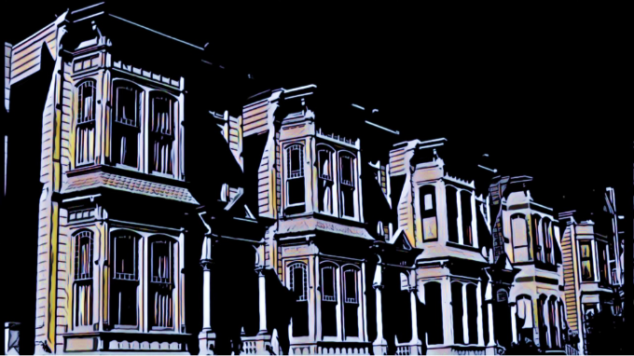
Billy was seventeen years old. He was wearing a new navy-blue overcoat, a new brown trilby hat, and a new brown suit, and he was feeling fine. He walked briskly down the street. He was trying to do everything briskly these days. Briskness, he had decided, was the one common characteristic of all successful businessmen. The big shots up at Head Office were absolutely fantastically brisk all the time. They were amazing.

There were no shops on this wide street that he was walking along, only a line of tall houses on each side, all of them identical. They had porches and pillars and four or five steps going up to their front doors, and it was obvious that once upon a time they had been very swanky residences. But now, even in the darkness, he could see that the paint was peeling from the woodwork on their doors and windows, and that the handsome white façades were cracked and blotchy from neglect.
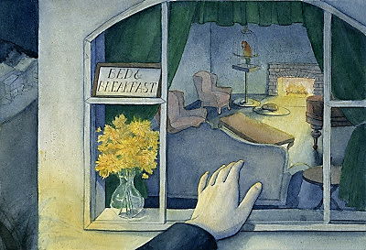
Suddenly, in a downstairs window that was brilliantly illuminated by a street-lamp not six yards away, Billy caught sight of a printed notice propped up against the glass in one of the upper panes. It said BED AND BREAKFAST. There was a vase of yellow chrysanthemums, tall and beautiful, standing just underneath the notice.

He stopped walking. He moved a bit closer. Green curtains (some sort of velvety material) were hanging down on either side of the window. The chrysanthemums looked wonderful beside them. He went right up and peered through the glass into the room, and the first thing he saw was a bright fire burning in the hearth. On the carpet in front of the fire, a pretty little dachshund was curled up asleep with its nose tucked into its belly.

The room itself, so far as he could see in the half-darkness, was filled with pleasant furniture. There was a baby-grand piano and a big sofa and several plump armchairs; and in one corner he spotted a large parrot in a cage. Animals were usually a good sign in a place like this, Billy told himself; and all in all, it looked to him as though it would be a pretty decent house to stay in. Certainly it would be more comfortable than The Bell and Dragon.

On the other hand, a pub would be more congenial than a boarding-house. There would be beer and darts in the evenings, and lots of people to talk to, and it would probably be a good bit cheaper, too. He had stayed a couple of nights in a pub once before and he had liked it. He had never stayed in any boarding-houses, and, to be perfectly honest, he was a tiny bit frightened of them. The name itself conjured up images of watery cabbage, rapacious landladies, and a powerful smell of kippers in the living-room.

After dithering about like this in the cold for two or three minutes, Billy decided that he would walk on and take a look at The Bell and Dragon before making up his mind. He turned to go. And now a peculiar thing happened to him. He was in the act of stepping back and turning away from the window when all at once his eye was caught and held in the most peculiar manner by the small notice that was there. BED AND BREAKFAST, it said. BED AND BREAKFAST, BED AND BREAKFAST, BED AND BREAKFAST. Each word was like a large black eye staring at him through the glass, holding him, compelling him, forcing him to stay where he was and not to walk away from that house, and the next thing he knew, he was actually moving across from the window to the front door of the house, climbing the steps that led up to it, and reaching for the bell. He pressed the bell. Far away in a back room he heard it ringing, and then at once – it must have been at once because he hadn’t even had time to take his finger from the bell-button – the door swung open and a woman was standing there.

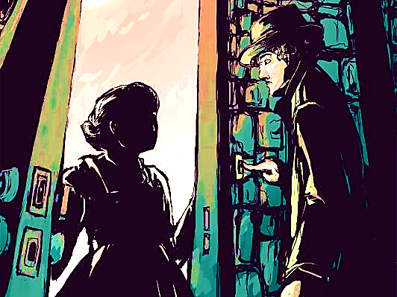
Normally you ring the bell and you have at least a half-minute’s wait before the door opens. But this dame was like a jack-in-the-box. He pressed the bell – and out she popped! It made him jump. She was about forty-five or fifty years old, and the moment she saw him, she gave him a warm welcoming smile.

“Please come in,” she said pleasantly. She stepped aside, holding the door wide open, and Billy found himself automatically starting forward into the house. The compulsion or, more accurately, the desire to follow after her into that house was extraordinarily strong.
“I saw the notice in the window,” he said, holding himself back.
“Yes, I know.”
“I was wondering about a room.”
“It's all ready for you, my dear,” she said. She had a round pink face and very gentle blue eyes.
“I was on my way to The Bell and Dragon,” Billy told her. “But the notice in your window just happened to catch my eye.”
“My dear boy,” she said, “why don't you come in out of the cold?”
“How much do you charge?”
“Five and sixpence a night, including breakfast.”
It was fantastically cheap. It was less than half of what he had been willing to pay.
“If that is too much,” she added, “then perhaps I can reduce it just a tiny bit. Do you desire an egg for breakfast? Eggs are expensive at the moment. It would be sixpence less without the egg.”
“Five and sixpence is fine,” he answered. “I should like very much to stay here.”
“I knew you would. Do come in.”

She seemed terribly nice. She looked exactly like the mother of your best school friend welcoming you into the house to stay for the Christmas holidays. Billy took off his hat, and stepped over the threshold.
“Just hang it there,” she said, “and let me help you with your coat.”
There were no other hats or coats in the hall. There were no umbrellas, no walking sticks – nothing.
“We have it all to ourselves,” she said, smiling at him over her shoulder as she led the way upstairs. “You see, it isn’t very often I have the pleasure of taking a visitor into my little nest.”
The old girl is slightly dotty, Billy told himself. But at five and sixpence a night, who gives a damn about that? – “I should've thought you’d be simply swamped with applicants,” he said politely.
“Oh, I am, my dear, I am, of course I am. But the trouble is that I'm inclined to be just a teeny weeny bit choosy and particular – if you see what I mean.”
“Ah, yes.”
“But I’m always ready. Everything is always ready day and night in this house just on the off-chance that an acceptable young gentleman will come along. And it is such a pleasure, my dear, such a very great pleasure when now and again I open the door and I see someone standing there who is just exactly right.”
She was half-way up the stairs, and she paused with one hand on the stair-rail, turning her head and smiling down at him with pale lips. “Like you,” she added, and her blue eyes travelled slowly all the way down the length of Billy's body, to his feet, and then up again.

On the first-floor landing she said to him, “This floor is mine.”
They climbed up a second flight. “And this one is all yours,” she said. “Here’s your room. I do hope you’ll like it.” She took him into a small but charming front bedroom, switching on the light as she went in. “The morning sun comes right in the window, Mr Perkins. It is Mr Perkins, isn’t it?”
“No,” he said. “It’s Weaver.”
“Mr Weaver. How nice. I’ve put a water bottle between the sheets to air them out, Mr Weaver. It’s such a comfort to have a hot water-bottle in a strange bed with clean sheets, don’t you agree? And you may light the gas fire at any time if you feel chilly.”
“Thank you,” Billy said. “Thank you ever so much.” He noticed that the bedspread had been taken off the bed, and that the bedclothes had been neatly turned back on one side, all ready for someone to get in. “I’m so glad you appeared,” she said, looking earnestly into his face. “I was beginning to get worried.”
“That’s all right,” Billy answered brightly. “You mustn’t worry about me.” He put his suitcase on the chair and started to open it.
“And what about supper, my dear? Did you manage to get anything to eat before you came here?”
“I’m not a bit hungry, thank you,” he said. “I think I’ll just go to bed as soon as possible because tomorrow I’ve got to get up rather early and report to the office.”
“Very well, then. I’ll leave you now so that you can unpack. But before you go to bed, would you be kind enough to pop into the sitting-room on the ground floor and sign the book? Everyone has to do that because it’s the law of the land, and we don’t want to go breaking any laws at this stage in the proceedings, do we?” She gave him a little wave of the hand and went quickly out of the room and closed the door.
Now, the fact that his landlady appeared to be slightly off her rocker didn’t worry Billy in the least. After all, she was not only harmless – there was no question about that – but she was also quite obviously a kind and generous soul. He guessed that she had probably lost a son in the war, or something like that, and had never got over it.
So a few minutes later, after unpacking his suitcase and washing his hands, he trotted downstairs to the ground floor and entered the living-room. His landlady wasn’t there, but the fire was glowing in the hearth, and the little dachshund was still sleeping in front of it. The room was wonderfully warm and cosy. I’m a lucky fellow, he thought, rubbing his hands. This is more than alright.

He found the guest-book lying open on the piano, so he took out his pen and wrote down his name and address. There were only two other entries above his on the page, and, as one always does with guest-books, he started to read them. One was a Christopher Mulholland from Cardiff. The other was Gregory W. Temple from Bristol. That’s funny, he thought suddenly. Christopher Mulholland. It rings a bell. Now where on earth had he heard that rather unusual name before?

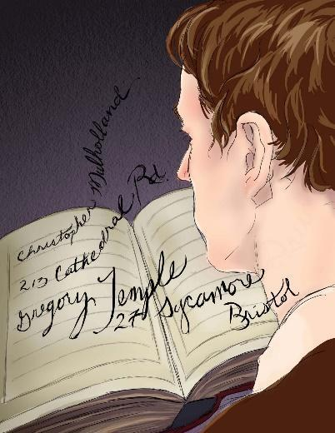
Was he a boy at school? No. Was it one of his sister’s numerous young men, perhaps, or a friend of his father’s? No, no, it wasn’t any of those. He glanced down again at the book. Christopher Mulholland, 231 Cathedral Road, Cardiff. Gregory W. Temple, 27 Sycamore Drive, Bristol. As a matter of fact, now he came to think of it, he wasn’t at all sure that the second name didn’t have almost as much of a familiar ring about it as the first.

“Gregory Temple?” he said aloud, searching his memory. “Christopher Mulholland? …”
“Such charming boys,” a voice behind him answered, and he turned and saw his landlady sailing into the room with a large silver tea-tray in her hands. She was holding it well out in front of her, and rather high up, as though the tray were a pair of reins on a frisky horse.
“They sound somehow familiar,” he said.
“They do? How interesting.”
“I’m almost positive I’ve heard those names before somewhere. Isn’t that strange? Maybe it was in the newspapers. They weren’t famous in any way, were they? I mean famous cricketers or footballers or something like that?”
“Famous,” she said, setting the tea-tray down on the low table in front of the sofa. “Oh no, I don’t think they were famous. But they were extraordinarily handsome, both of them, I can promise you that. They were tall and young and handsome, my dear, just exactly like you.”

Once more, Billy glanced down at the book.
“Look here,” he said, noticing the dates. “This last entry is over two years old.”
“It is?”
“Yes, indeed. And Christopher Mulholland’s is nearly a year before that – more than three years ago.”
“Dear me,” she said, shaking her head and heaving a dainty little sigh. “I would never have thought it. How time does fly away from us all, doesn’t it, Mr Wilkins?”
“It’s Weaver,” Billy said. “W-e-a-v-e-r.” “Oh, of course it is!” she cried, sitting down on the sofa. “How silly of me. I do apologise. In one ear and out the other, that’s me, Mr Weaver.”

“You know something?” Billy said. ‘Something that’s really quite extraordinary about all this?”
“No, dear, I don’t.”
“Well, you see – both of these names, Mulholland and Temple, I not only seem to remember each one of them separately, so to speak, but somehow or other, in some peculiar way, they both appear to be sort of connected together as well. As though they were both famous for the same sort of thing, if you see what I mean – like… like Dempsey and Tunney, for example, or Churchill and Roosevelt.”
“How amusing,” she said. “But come over here now, dear, and sit down beside me on the sofa and I’ll give you a nice cup of tea and a ginger biscuit before you go to bed.”
“You really shouldn’t bother,” Billy said. “I didn’t mean you to do anything like that.” He stood by the piano, watching her as she fussed about with the cups and saucers. He noticed that she had small, white, quickly moving hands, and red finger-nails.
“I’m almost positive it was in the newspapers I saw them,” Billy said. “I’ll think of it in a second. I’m sure I will.” There is nothing more tantalising than a thing like this which lingers just outside the borders of your memory. He hated to give up.
“Now wait a minute,” he said. “Wait just a minute. Mulholland... Christopher Mulholland... wasn’t that the name of the Eton schoolboy who was on a walking-tour through the West Country, and then all of a sudden...”
“Milk?” she said. “And sugar?”
“Yes, please. And then all of a sudden ...”
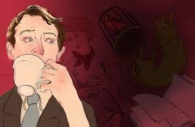
“Eton schoolboy?” she said. “Oh no, my dear, that can’t possibly be right because my Mr Mulholland was certainly not an Eton schoolboy when he came to me. He was a Cambridge undergraduate. Come over here now and sit next to me and warm yourself in front of this lovely fire. Come on. Your tea’s all ready for you.” She patted the empty place beside her on the sofa, and she sat there smiling at Billy and waiting for him to come over. He crossed the room slowly, and sat down on the edge of the sofa. She placed his teacup on the table in front of him.
“There we are,” she said. “How nice and cosy this is, isn’t it?”

Billy started sipping his tea. She did the same. For half a minute or so, neither of them spoke. But Billy knew that she was looking at him. Her body was half-turned towards him, and he could feel her eyes resting on his face, watching him over the rim of her teacup. Now and again, he caught a whiff of a peculiar smell that seemed to emanate directly from her person. It was not in the least unpleasant, and it reminded him – well, he wasn’t quite sure what it reminded him of. Pickled walnuts? New leather? Or was it the corridors of a hospital?

“Mr Mulholland was a great one for his tea,” she said at length. “Never in my life have I seen anyone drink as much tea as dear, sweet Mr Mulholland.”
“I suppose he left fairly recently,” Billy said. He was still puzzling his head about the two names. He was positive now that he had seen them in the newspapers – in the headlines.
“Left?” she said, arching her brows. “But my dear boy, he never left. He’s still here. Mr Temple is also here. They’re on the third floor, both of them together.”

Billy set down his cup slowly on the table, and stared at his landlady. She smiled back at him, and then she put out one of her white hands and patted him comfortingly on the knee.
“How old are you, my dear?” she asked.
“Seventeen.”
“Seventeen!” she cried. “Oh, it’s the perfect age! Mr Mulholland was also seventeen. But I think he was a trifle shorter than you are, in fact I’m sure he was, and his teeth weren’t quite so white. You have the most beautiful teeth, Mr Weaver, did you know that?”
“They’re not as good as they look,” Billy said. “They’ve got simply masses of fillings in them at the back.”
“Mr Temple, of course, was a little older,” she said, ignoring his remark. “He was actually twenty eight. And yet I never would have guessed it if he hadn’t told me, never in my whole life. There wasn’t a blemish on his body.”
“A what?” Billy said.
“His skin - was just like a baby’s.”

There was a pause. Billy picked up his teacup and took another sip of his tea, then he set it down again gently in its saucer. He waited for her to say something else, but she seemed to have lapsed into another of her silences. He sat there staring straight ahead of him into the far corner of the room, biting his lower lip.
“That parrot,” he said at last. “You know something? It had me completely fooled when I first saw it through the window from the street. I could have sworn it was alive.”
“Alas, no longer.”
“It’s most terribly clever the way it’s been done,” he said. “It doesn’t look in the least bit dead. Who did it?”
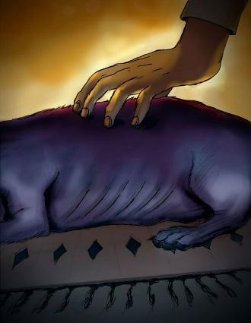
“I did.”
“You did?”
“Of course,” she said. “And have you met my little Basil as well?” She nodded towards the dachshund curled up so comfortably in front of the fire. Billy looked at it. And suddenly, he realised that this animal had all the time been just as silent and motionless as the parrot. He put out a hand and touched it gently on the top of its back. The back was hard and cold, and when he pushed the hair to one side with his fingers, he could see the skin underneath, greyish-black and dry and perfectly preserved.

“Good gracious me,” he said. “How absolutely fascinating.” He turned away from the dog and stared with deep admiration at the little woman beside him on the sofa. “It must be most awfully difficult to do a thing like that.”
“Not in the least,” she said. “I stuff all my little pets myself when they pass away. Will you have another cup of tea?”
“No, thank you,” Billy said. The tea tasted faintly of bitter almonds, and he didn’t much care for it.

“You did sign the book, didn’t you?”
“Oh, yes.”
“That’s good. Because later on, if I happen to forget what you were called, then I can always come down here and look it up. I still do that almost every day with Mr Mulholland and Mr… Mr...”
“Temple,” Billy said. “Gregory Temple. Excuse my asking, but haven’t there been any other guests here except them in the last two or three years?”

Holding her teacup high in one hand, inclining her head slightly to the left, she looked up at him out of the corners of her eyes and gave him another gentle little smile. “No, my dear,” she said. ‘Only you.'

The Bridge

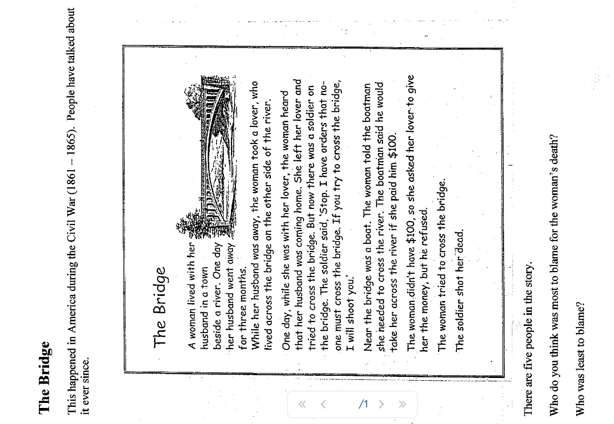

The Dogs by Hanif Kureishi

This brief but chilling short story describes a woman and her young son crossing a dark field at night. Although the events leading up to this moment remain unexplained, the story explores the fear and paranoia that exist in modern society: the urban legends of animal attacks, the dangers of going out after dark, and the very real fears parents have for the safety of their children – the worry that no matter what they do they cannot ever fully protect them from the horrors of the world.


Overnight it had been raining, but to one side of the precipitous stone steps there was a rail to grip on to. With her free hand she took her son's wrist, dragging him back when he lost his footing. It was too perilous for her to pick him up, and at five years old he was too heavy to be carried far.
Branches heavy with sticky leaves trailed across the steps, sometimes blocking their way so they had to climb over or under them. The steps themselves twisted and turned and were worn and often broken. There were more of them than she'd expected. She had never been this way, but had been told it was the only path, and that the man would be waiting for her on the other side of the area.
When they reached the bottom of the steps, her son's mood improved and he called, "Chase me". This was his favourite game and he set off quickly across the grass, which alarmed her, though she didn't want to scare him with her fears. She pursued him through the narrow, wooded area ahead, losing him for a moment. She had to call out for him several times until at last she heard his reply.
Their feet kept sinking into the lush ground but a discernible track emerged. Soon they were in the open. It was a common rather than a park, and would take about 40 minutes to cross: that was what she had been told.
Though it was a long way off, only a dot in the distance, she noticed the dog right away. Almost immediately the animal seemed bigger, a short-legged, compact bullet. She knew all dogs were of different breeds: Dalmatians and Chihuahuas and so on, but she had never retained the names. As the dog neared her son, she wondered if it wasn't chasing a ball hidden in the grass. But there was no ball that she could see, and the little speeding dog with its studded collar had appeared from nowhere, sprinting across the horizon like a shadow, before turning in their direction. There was no owner in sight; there were no other humans she could see.
The boy saw the dog and stopped, tracking it with curiosity and then with horror. What could his mother do but cry out and begin to run? The dog had already knocked down her son and began not so much to bite him as to eat him, furiously.
She was wearing heavy, loosely-laced shoes and was able to give the dog a wild blow in the side, enough to distract it, so that it looked bemused. She pulled the boy to her, but it was impossible for her to examine his wounds because she then had to hold him as high as she could while stumbling along, with the dog still beside her, barking, leaping and twisting in the air. She could not understand why she had no fascination for the dog.
She began to shout, to scream, panicking because she wouldn't be able to carry her son far. Tiring, she stopped and kicked out at the dog again, this time hitting him in the mouth, which made him lose hope.
Immediately a big long-haired dog was moving in the bushes further away, racing towards them. As it took off to attack the child, she was aware, around her, of numerous other dogs, in various colours and sizes, streaming out of the undergrowth from all directions. Who had called them? Why were they there?
She lost her footing, she was pushed over and was huddled on the ground, trying to cover her son, as the animals noisily set upon her, in a ring. To get him they would have to tear through her, but it wouldn't take long, there were so many of them, and they were hungry, too.

Fish Cheeks Amy Tan

Amy Tan’s autobiographical short story recalls a simple but formative memory of a Christmas Eve dinner from her childhood. Subtle and yet powerful, the narrative explores the link between food, eating, family and identity.

I fell in love with the minister's son the winter I turned fourteen. He was not Chinese, but as white as Mary in the manger. For Christmas I prayed for this blond-haired boy, Robert, and a slim new
American nose.

When I found out that my parents had invited the minister's family over for Christmas Eve dinner,
I cried. What would Robert think of our shabby Chinese Christmas? What would he think of our noisy
Chinese relatives who lacked proper American manners? What terrible disappointment would he feel
upon seeing not a roasted turkey and sweet potatoes but Chinese food?

On Christmas Eve I saw that my mother had outdone herself in creating a strange menu. She was
pulling black veins out of the backs of fleshy prawns. The kitchen was littered with appalling mounds of
raw food: A slimy rock cod with bulging eyes that pleaded not to be thrown into a pan of hot oil. Tofu,
which looked like stacked wedges of rubbery white sponges. A bowl soaking dried fungus back to life.
A plate of squid, their backs crisscrossed with knife markings so they resembled bicycle tires.

And then they arrived – the minister's family and all my relatives in a clamour of doorbells and
rumpled Christmas packages. Robert grunted hello, and I pretended he was not worthy of existence.


Dinner threw me deeper into despair. My relatives licked the ends of their chopsticks and reached
across the table, dipping them into the dozen or so plates of food. Robert and his family waited patiently
for platters to be passed to them. My relatives murmured with pleasure when my mother brought out the
whole steamed fish. Robert grimaced. Then my father poked his chopsticks just below the fish eye and
plucked out the soft meat. "Amy, your favourite," he said, offering me the tender fish cheek. I wanted to
disappear.

At the end of the meal my father leaned back and belched loudly, thanking my mother for her fine
cooking. "It's a polite Chinese custom to show you are satisfied," explained my father to our astonished
guests. Robert was looking down at his plate with a reddened face. The minister managed to muster up a
quiet burp. I was stunned into silence for the rest of the night.

After everyone had gone, my mother said to me, "You want to be the same as American girls on
the outside." She handed me an early gift. It was a miniskirt in beige tweed. "But inside you must
always be Chinese. You must be proud you are different. Your only shame is to have shame."

And even though I didn't agree with her then, I knew that she understood how much I had suffered
during the evening's dinner. It wasn't until many year later – long after I had gotten over my crush on
Robert – that I was able to fully appreciate her lesson and the true purpose behind our particular menu.
For Christmas Eve that year, she had chosen all my favourite foods.

Examination Day by Henry Seslar

Set in the technologically-advanced future, this story is about a twelve year old boy who learns that he must undergo a government intelligence exam.


The Jordans never spoke of the exam, not until their son, Dickie, was twelve years old. It was on his birthday that Mrs Jordan first mentioned the subject in his presence, and the anxious manner of her speech caused her husband to answer sharply.
‘Forget about it,’ he said. ‘He’ll do alright.’
They were at the breakfast table, and the boy looked up from his plate curiously. He was an alert-eyed youngster, with flat blond hair and a quick, nervous manner. He didn’t understand what the sudden tension was about, but he did know that today was his birthday, and he wanted harmony above all. Somewhere in the apartment there were wrapped, beribboned packages waiting to be opened, and in the tiny wall-kitchen, something warm and sweet was being prepared in the automatic stove. He wanted the day to be happy, and the moistness of his mother’s eyes, the scowl on his father’s face, spoiled the mood of fluttering expectation with which he had greeted the morning.
‘What exam?’ he asked.
His mother looked at the tablecloth. ‘It’s just a sort of Government intelligence test they give children at the age of twelve. You’ll be getting it next week. It’s nothing to worry about.’

‘You mean a test like in school?’
‘Something like that,’ his father said, getting up from the table. ‘Go read your comic books, Dickie.’
The boy rose and wandered towards that part of the room that had been ‘his’ corner since infancy. He fingered the topmost comic of the stack, but seemed uninterested in the colourful squares of fast-paced action. He wandered towards the window, and peered gloomily at the veil of mist that shrouded the glass.
‘Why did it have to rain today?’ he said. ‘Why couldn’t it rain tomorrow?’
His father, now slumped into an armchair with the Government newspaper, rattled the sheets in vexation. ‘Because it just did, that’s all. Rain makes the grass grow.’
‘Why, Dad?’

‘Because it does, that’s all.’ Dickie puckered his brow.
‘What makes it green, though? The grass?’
‘Nobody knows,’ his father snapped, then immediately regretted his abruptness.
Later in the day, it was birthday time again. His mother beamed as she handed over the gaily–coloured packages, and even his father managed a grin and a rumple-of-the-hair. He kissed his mother and shook hands gravely with his father. Then the birthday cake was brought forth, and the ceremonies concluded.
‘Dad,’ he said, ‘how far away is the sun?’
‘Five thousand miles,’ his father said.

⬧⬧⬧⬧⬧⬧⬧⬧⬧⬧⬧⬧⬧⬧⬧⬧⬧⬧⬧⬧

Dick sat at the breakfast table and again saw the moisture in his mother’s eyes. He didn’t connect her tears with the exam until his father suddenly brought the subject to light again.
‘Well, Dickie,’ he said, with a manly frown, ‘you’ve got an appointment today.’
‘I know, Dad. I hope—‘
‘Now it’s nothing to worry about. Thousands of children take this test every day. The Government wants to know how smart you are, Dickie. That’s all there is to it.’
‘I get good marks in school,’ he said hesitantly.
‘This is different. This is– a special kind of test. They give you this stuff to drink, you see, and then you go into a room where there’s a sort of machine—‘
‘What stuff to drink?’ Dickie said.
‘It’s nothing. It tastes like peppermint. It’s just to make sure you answer the questions truthfully. Not that the Government thinks you won’t tell the truth, but this stuff makes sure.’
Dickie’s face showed puzzlement, and a touch of fright. He looked at his mother, and she composed her face into a misty smile.
‘Everything will be alright,’ she said.
‘Of course it will,’ his father agreed. ‘You’re a good boy, Dickie; you’ll make out fine. Then we’ll come home and celebrate. All right?’
‘Yes, sir,’ Dickie said.

⬧⬧⬧⬧⬧⬧⬧⬧⬧⬧⬧⬧⬧⬧⬧⬧⬧⬧⬧⬧


They entered the Government Educational Building fifteen minutes before the appointed hour. They crossed the marble floors of the great pillared lobby, passed beneath an archway and entered an automatic elevator that brought them to the fourth floor.
There was a young man wearing an insignia-less tunic, seated at a polished desk in front of Room 404. He held a clipboard in his hand, and he checked the list down to the Js and permitted the Jordans to enter.
The room was as cold and official as a courtroom, with long benches flanking metal tables. There were several fathers and sons already there, and a thin-lipped woman with cropped black hair was passing out sheets of paper.
Mr Jordan filled out the form, and returned it to the clerk. Then he told Dickie: ‘It won’t be long now. When they call out your name, you just go through the doorway at that end of the room.’ He indicated the portal with his finger.
A concealed loudspeaker crackled and called off the first name. Dickie saw a boy leave his father’s side reluctantly and walk slowly towards the door.
At five minutes of eleven, they called the name of Jordan.

‘Good luck, son,’ his father said, without looking at him. ‘I’ll call for you when the test is over.’
Dickie walked to the door and turned the knob. The room inside was dim, and he could barely make out the features of the grey-tunicked attendant who greeted him.
‘Sit down,’ the man said softly. He indicated a high stool beside his desk. ‘Your name’s Richard Jordan?’
‘Yes, sir.’
‘Your classification number is 600-115. Drink this, Richard.’
He lifted a plastic cup from the desk and handed it to the boy. The liquid inside had the consistency of buttermilk, but tasted only vaguely of the promised peppermint. Dickie downed it, and handed the man the empty cup.
He sat in silence, feeling drowsy, while the man wrote busily on a sheet of paper. Then the attendant looked at his watch, and rose to stand only inches from Dickie’s face. He unclipped a pen-like object from the pocket of his tunic, and flashed a tiny light into the boy’s eyes.
‘All right,’ he said. ‘Come with me, Richard.’
He led Dickie to the end of the room, where a single wooden armchair faced a multidialled computing machine. There was a microphone on the left arm of the chair, and when the boy sat down, he found its pinpoint head conveniently at his mouth.
‘Now just relax, Richard. You’ll be asked some questions, and you think them over carefully. Then give your answers into the microphone. The machine will take care of the rest.’
‘Yes, sir.’
‘I’ll leave you alone now. Whenever you want to start, just say “ready” into the microphone.’
‘Yes, sir.’
The man squeezed his shoulder, and left.
Dickie said, ‘Ready.’
Lights appeared on the machine, and a mechanism whirred. A voice said: ‘Complete this sequence. One, four, seven, ten…’

⬧⬧⬧⬧⬧⬧⬧⬧⬧⬧⬧⬧⬧⬧⬧⬧⬧⬧⬧⬧

Mr and Mrs Jordan were in the living room, not speaking, not even speculating.

It was almost four o’clock when the telephone rang. The woman tried to reach it first, but her husband was quicker.
‘Mr Jordan?’ The voice was clipped; a brisk, official voice.
‘Yes, speaking.’
‘This is the Government Education Service. Your son, Richard M Jordan, Classification 600-115, has completed the Government examination. We regret to inform you that his intelligence quotient has exceeded the Government regulation, according to Rule 84, Section 5, of the New Code.’
Across the room, the woman cried out, knowing nothing except the emotion she read on her husband’s face.
‘You may wish to specify by telephone,’ the voice droned on, ‘whether you wish his body interred by the Government or would you prefer a private burial place? The fee for Government burial is ten dollars.’

Charles by Shirley Jackson

In this short story, a mother and father notice how suddenly their son’s behaviour changes when he begins school.

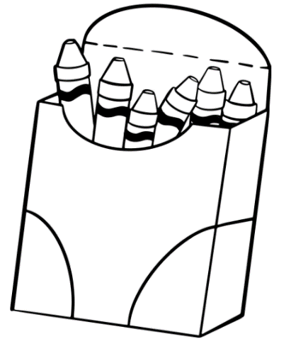
The day my son Laurie started kindergarten he renounced corduroy overalls with bibs and began wearing blue jeans with a belt; I watched him go off the first morning with the older girl next door, seeing clearly that an era of my life was ended, my sweet-voiced nursery-school tot replaced by a longtrousered, swaggering character who forgot to stop at the corner and wave good-bye to me.
He came home the same way, the front door slamming open, his cap on the floor, and the voice suddenly become raucous shouting, “Isn’t anybody here?”
At lunch he spoke insolently to his father, spilled his baby sister’s milk, and remarked that his teacher said we were not to take the name of the Lord in vain.
“How was school today?” I asked, elaborately casual.
“All right,” he said.
“Did you learn anything?” his father asked.
Laurie regarded his father coldly. “I didn’t learn nothing,” he said.
“Anything,” I said. “Didn’t learn anything”
“The teacher spanked a boy, though,” Laurie said, addressing his bread and butter. “For being fresh,” he added, with his mouth full.
“What did he do?” I asked. “Who was it?”
Laurie thought. “It was Charles,” he said. “He was fresh. The teacher spanked him and made him stand in a corner. He was awfully fresh.”
“What did he do?” I asked again, but Laurie slid off his chair, took a cookie, and left, while his father was still saying, “See here, young man.”

The next day Laurie remarked at lunch, as soon as he sat down, “Well, Charles was bad again today.” He grinned enormously and said, “Today Charles hit the teacher.”
“Good heavens,” I said, mindful of the Lord’s name, “I suppose he got spanked again?”
“He sure did,” Laurie said. “Look up,” he said to his father.
“What?” his father said, looking up.
“Look down,” Laurie said. “Look at my thumb. Gee, you’re dumb.” He began to laugh insanely.
“Why did Charles hit the teacher?” I asked quickly.
“Because she tried to make him colour with red crayons,” Laurie said. “Charles wanted to colour with green crayons so he hit the teacher and she spanked him and said nobody play with Charles but everybody did.”

The third day—it was Wednesday of the first week—Charles bounced a see-saw onto the head of a little girl and made her bleed, and the teacher made him stay inside all during recess. Thursday Charles had to stand in a corner during storytime because he kept pounding his feet on the floor. Friday Charles was deprived of blackboard privileges because he threw chalk. On Saturday I remarked to my husband, “Do you think kindergarten is too unsettling for Laurie? All this toughness, and bad grammar, and this Charles boy sounds like such a bad influence.”
“It’ll be alright,” my husband said reassuringly. “Bound to be people like Charles in the world. Might as well meet them now as later.”
On Monday Laurie came home late, full of news. “Charles,” he shouted as he came up the hill; I was waiting anxiously on the front steps. “Charles,” Laurie yelled all the way up the hill, “Charles was bad again.”
“Come right in,” I said, as soon as he came close enough. “Lunch is waiting.”
“You know what Charles did?” he demanded, following me through the door. “Charles yelled so in school they sent a boy in from first grade to tell the teacher she had to make Charles keep quiet, and so Charles had to stay after school. And so all the children stayed to watch him.”
“What did he do?” I asked.
“He just sat there,” Laurie said, climbing into his chair at the table. “Hi, Pop, y’old dust mop.”
“Charles had to stay after school today,” I told my husband. “Everyone stayed with him.”
“What does this Charles look like?” my husband asked Laurie. “What’s his other name?”
“He’s bigger than me,” Laurie said. “And he doesn’t have any rubbers and he doesn’t ever wear a jacket.”

Monday night was the first Parent-Teachers meeting, and only the fact that the baby had a cold kept me from going; I wanted passionately to meet Charles’s mother. On Tuesday Laurie remarked suddenly, “Our teacher had a friend come to see her in school today.”
“Charles’s mother?” my husband and I asked simultaneously.
“Naaah,” Laurie said scornfully. “It was a man who came and made us do exercises, we had to touch our toes. Look.” He climbed down from his chair and squatted down and touched his toes. “Like this,” he said. He got solemnly back into his chair and said, picking up his fork, “Charles didn’t even do exercises.”
“That’s fine,” I said heartily. “Didn’t Charles want to do exercises?”
“Naaah,” Laurie said. “Charles was so fresh to the teacher’s friend he wasn’t allowed to do exercises.”
“Fresh again?” I said.
“He kicked the teacher’s friend,” Laurie said. “The teacher’s friend told Charles to touch his toes like I just did and Charles kicked him.”
“What are they going to do about Charles, do you suppose?” Laurie’s father asked him.
Laurie shrugged elaborately. “Throw him out of school, I guess,” he said.

Wednesday and Thursday were routine; Charles yelled during story hour and hit a boy in the stomach and made him cry. On Friday Charles stayed after school again and so did all the other children. With the third week of kindergarten Charles was an institution in our family; the baby was being a Charles when she cried all afternoon; Laurie did a Charles when he filled his wagon full of mud and pulled it through the kitchen; even my husband, when he caught his elbow in the telephone cord and pulled telephone, ashtray, and a bowl of flowers off the table, said, after the first minute, “Looks like Charles.” During the third and fourth weeks it looked like a reformation in Charles; Laurie reported grimly at lunch on Thursday of the third week, “Charles was so good today the teacher gave him an apple.”
“What?” I said, and my husband added warily, “You mean Charles?”
“Charles,” Laurie said.
“He gave the crayons around and he picked up the books afterward and the teacher said he was her helper.”
“What happened?” I asked incredulously.
“He was her helper, that’s all,” Laurie said, and shrugged.
“Can this be true, about Charles?” I asked my husband that night. “Can something like this happen?”
“Wait and see,” my husband said cynically. “When you’ve got a Charles to deal with, this may mean he’s only plotting.”
He seemed to be wrong. For over a week Charles was the teacher’s helper; each day he handed things out and he picked things up; no one had to stay after school.
“The P.T.A. meeting’s next week again,” I told my husband one evening. “I’m going to find Charles’s mother there.”
“Ask her what happened to Charles,” my husband said. “I’d like to know.”
“I’d like to know myself,” I said.

On Friday of that week things were back to normal. “You know what Charles did today?” Laurie demanded at the lunch table, in a voice slightly awed.
“He told a little girl to say a word and she said it and the teacher washed her mouth out with soap and Charles laughed.”
“What word?” his father asked unwisely, and Laurie said,
“I’ll have to whisper it to you, it’s so bad.” He got down off his chair and went around to his father. His father bent his head down and Laurie whispered joyfully. His father’s eyes widened.
“Did Charles tell the little girl to say that?” he asked respectfully.
“She said it twice,” Laurie said. “Charles told her to say it twice.”
“What happened to Charles?” my husband asked.
“Nothing,” Laurie said. “He was passing out the crayons.”

Monday morning Charles abandoned the little girl and said the evil word himself three or four times, getting his mouth washed out with soap each time. He also threw chalk.
My husband came to the door with me that evening as I set out for the P.T.A. meeting. “Invite her over for a cup of tea after the meeting,” he said. “I want to get a look at her.”
“If only she’s there,” I said prayerfully.
“She’ll be there,” my husband said. “I don’t see how they could hold a P.T.A. meeting without Charles’s mother.” At the meeting I sat restlessly, scanning each comfortable matronly face, trying to determine which one hid the secret of Charles. None of them looked to me haggard enough. No one stood up in the meeting and apologised for the way her son had been acting. No one mentioned Charles.
After the meeting I identified and sought out Laurie’s kindergarten teacher. She had a plate with a cup of tea and a piece of chocolate cake; I had a plate with a cup of tea and a piece of marshmallow cake. We manoeuvred up to one another cautiously, and smiled.
“I’ve been so anxious to meet you,” I said. “I’m Laurie’s mother.”
“We’re all so interested in Laurie,” she said.
“Well, he certainly likes kindergarten,” I said. “He talks about it all the time.”
“We had a little trouble adjusting, the first week or so,” she said primly, “but now he’s a fine little helper. With occasional lapses, of course.”
“Laurie usually adjusts very quickly,” I said. “I suppose this time it’s Charles’s influence.”
“Charles?”
“Yes,” I said, laughing, “you must have your hands full in that kindergarten, with Charles.”
“Charles?” she said. “We don’t have any Charles in the kindergarten.”

Sredni Vashtar by H. H. Munro (Saki)

H. H. Munro, also known by the pen name Saki, wrote this short story during the early 1900s. It is about Conradin, a sickly 10-year old boy, who lives in the care of his strict and overbearing cousin, Mrs De Ropp. He relies on his vivid imagination not only to keep him strong enough to survive, but also to rebel against Mrs De Ropp.

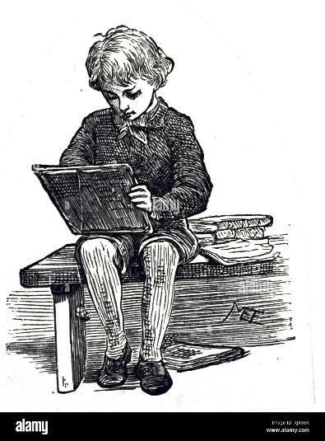
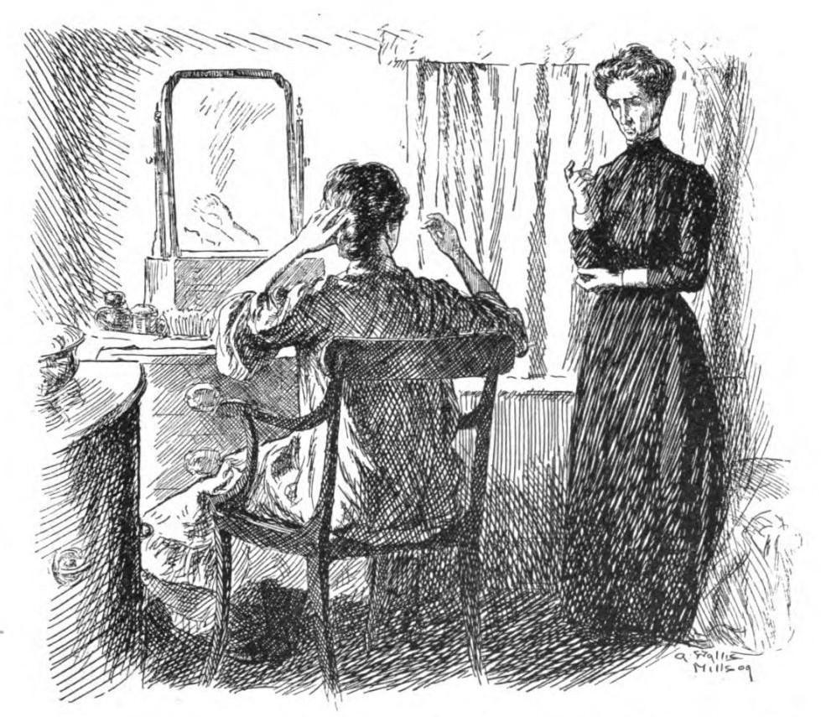
Conradin was ten years old, and the doctor had given his professional opinion that the boy would not live another five years. The doctor counted for little, but his opinion was supported by Mrs De Ropp who counted for nearly everything. Mrs De Ropp was Conradin’s cousin and guardian, and for him she represented those three-fifths of the world that are necessary and unpleasant and real; the other two-fifths were himself and his imagination. One of these days Conradin supposed he would give in to the pressure of miserable reality and die. Without his imagination, he would have died long ago.
Mrs De Ropp would never have admitted to herself that she disliked Conradin, though she was dimly aware that stopping him doing things ‘for his own good’ was a duty she didn’t find unpleasant. Conradin hated her with a desperate sincerity which he was able to hide perfectly. The few pleasures he could find for himself were increased by knowing they would displease her if she found out about them, and in particular she was locked out from the world of his imagination – an unclean thing that would never enter it.
He found little attraction in the dull cheerless garden, which was overlooked by so many windows ready to open with a message not to do this or that, or a reminder that his medicines were due. He wasn’t allowed to pick anything from the few fruit trees. But in a forgotten corner, almost hidden behind a dismal shrubbery, was a disused tool-shed of reasonable size, and in it Conradin found a refuge – partly a playroom and partly a cathedral. He had peopled it with friends from his imagination, but it also housed two real creatures.

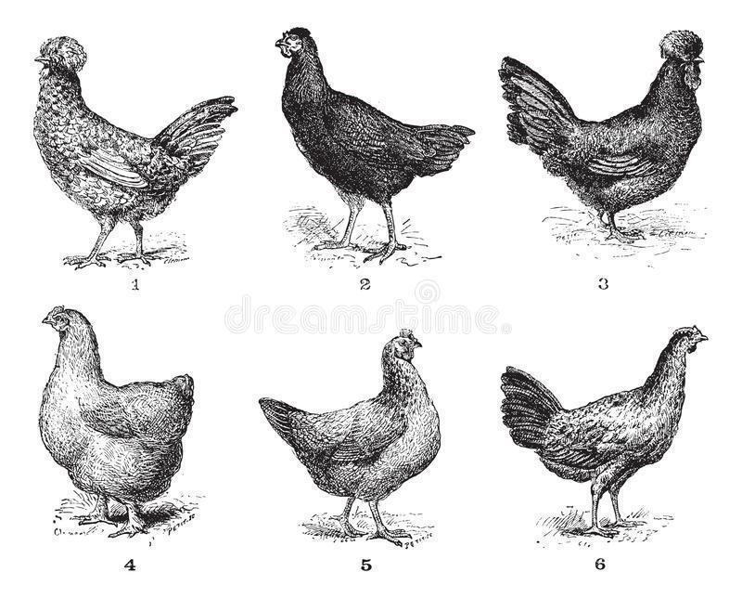
In one corner lived a ragged Houdan hen on which he lavished all the affection he could show to no-one else. Further back in the gloom stood a large hutch, divided into two compartments, one of which was fronted with close iron bars. This was the home of a large polecat-ferret which a friendly butcher-boy had smuggled in, cage and all, in return for the small amount of money that Conradin had secretly saved. Conradin was very afraid of the lithe, sharp-fanged creature, but it was his most treasured possession. Its very presence in the tool-shed was a secret and fearful joy, to be kept completely from the Woman as he privately called his cousin.
And one day, from Heaven knows what material, he created a wonderful name for the beast, and from that moment it grew into a god and a religion. The Woman indulged in religion once a week at the church nearby and made Conradin go with her, but the church service meant nothing to him. Every Thursday, in the dim and musty silence of the tool-shed, he worshipped before the wooden hutch where lived Sredni Vashtar, the great ferret. He lay red flowers in their season and scarlet berries in the winter-time in front of the hutch as if it were a shrine. And on great festivals he scattered powdered nutmeg there, the important feature being that the nutmeg was stolen from the kitchen. These festivals were irregular and celebrated some event. On one occasion, when Mrs De Ropp suffered acute toothache for three days, Conradin kept up the festival for the full three days and almost persuaded himself that Sredni Vashtar had caused the toothache. If it had lasted another day, the household supply of nutmeg would have given out.
After a while Conradin’s visits to the tool-shed attracted the notice of his guardian. “It’s not good for him to be pottering down there is all weathers,” she promptly decided, and at breakfast one morning she announced that the Houdan hen had been sold and taken away overnight. With her short-sighted eyes she peered at Conradin, waiting for him to show anger or sorrow which she was ready to answer with reasons and advice. But Conradin said nothing: there was nothing to be said. Perhaps something in his white set face gave her a momentary pause, for at tea that afternoon there was toast on the table, a delicacy which she usually banned on the ground that it was bad for him; also because making it ‘gave the servants trouble’.
“I thought you liked toast,” she exclaimed in an injured tone when he didn’t touch it.
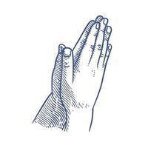
“Sometimes,” said Conradin.
In the shed that evening there was a change in the worship of the hutch-god. Conradin had previously chanted his praises; tonight he asked a favour.
“Do one thing for me, Sredni Vashtar.”
He did not say what the thing was. As Sredni Vashtar was a god, he would know what it was. And choking back a sob as he looked at the other empty corner, Conradin went back to the world he hated so much.
And every night, in the welcome darkness of his bedroom, and every evening in the dusk of the tool-shed, Conradin’s bitter prayer went up: “Do one thing for me, Sredni Vashtar.”
Mrs De Ropp noticed that his visits to the shed did not cease, and she made a further journey of inspection.
“What are you keeping in that locked hutch?” she asked. “I believe it’s guinea-pigs. I’ll have them cleared away.”

Conradin shut his lips tight, but the Woman ransacked his bedroom till she found the carefully hidden key, and she straightway marched down to the shed. It was a cold afternoon and Conradin had been told to keep indoors. From the furthest window of the dining-room, the door of the shed could just be seen beyond the corner of the shrubbery, and there Conradin stationed himself. He saw the Woman enter and he imagined her opening the door of the sacred hutch and peering down with her short-sighted eyes into the thick straw where his god lay hidden. Perhaps she would prod at the straw with her clumsy impatience. And Conradin breathed his prayer for the last time.
But he knew as he prayed that he didn’t really believe. He knew the Woman would come out presently with that pursed smile he loathed so much on her face, and within an hour or two the gardener would carry away his wonderful god – a god no longer but just a big brown ferret in a hutch. And he knew the Woman would triumph always as she triumphed now, and he would grow ever more sickly under her pestering and domineering till one day nothing would matter anymore and the doctor would be proved right. And in the sting and misery of his defeat, he began to chant loudly and defiantly the hymn he had made up for his idol:
Sredni Vashtar went forth,
His thoughts were red thoughts and his teeth were white.
His enemies called for peace, but he brought them death.
Sredni Vashtar the Beautiful.
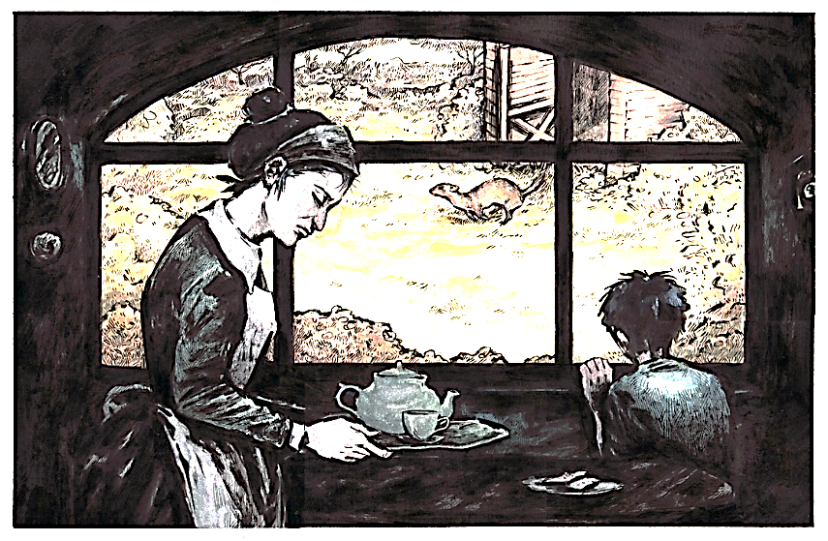
And then he stopped his chanting and drew closer to the window. The door of the shed stood ajar, blown to and fro in the cold breeze, and the minutes were slipping by. They were long minutes, but they slipped by nevertheless. He watched the starlings running and flying in little groups across the lawn; he counted them over and over again with one eye always on the swinging door. A sour-faced maid came in to lay the table for tea, and still Conradin stood and waited and watched. Hope crept by inches into his heart, and now a look of triumph began to blaze in his eyes which had only known the wistful patience of defeat. Under his breath he chanted his prayer, but this time it was a cry of victory and devastation.
And presently his eyes were rewarded: out through the doorway came a long, low, yellow-and-brown creature, eyes blinking in the daylight, and dark wet stains round the fur of its jaws and throat. Conradin dropped on his knees. The great polecat-ferret made its way down to a small brook at the foot of the garden, drank for a moment, then crossed a little plank bridge and was lost to sight in the bushes. Such was the passing of Sredni Vashtar.
“Tea is ready,” said the sour-faced maid, “where is the mistress?”
“She went down to the shed some time ago,” said Conradin.
And while the maid went to summon her mistress for tea, Conradin fished a toasting-fork out of the sideboard drawer and proceeded to toast himself a piece of bread. And during the toasting of it and the buttering of it with much butter and the slow enjoyment of eating it, Conradin listened to the noises and silences beyond the dining-room door. The loud foolish screaming of the maid, the answering chorus of cries from the kitchen area, the scuttering footsteps and hurried exits to fetch outside help, and then, after a lull, the scared sobbings and shuffling tread of those who carried a heavy burden into the house.
“Whoever will break it to the poor child?” exclaimed a shrill voice. “I couldn’t for the life of me!” And while they debated this among themselves, Conradin made himself another piece of toast.

